Appendix S1
False Positive Catamenial Epilepsy Classification: A Simulation Study
Development and calibration of HORMONE-CYCLE and supplementary study methods

Table of Contents
Chapter 1. Development of HORMONE-CYCLE 3
1.1 Purpose, scope, and intended use 3
1.2 Evidence review and role of each source 3
1.3 Workflow and data hierarchy 7
1.3.1 Inputs and outputs 7
1.4 Age-specific patient-level parameters 7
1.5 Cycle length, phase timing, and bleeding 9
1.6 Daily hormone trajectories 9
1.7 Reproductive-stage and medical modifiers 12
1.7.1 Polycystic ovary syndrome 12
1.7.2 Early postmenarche 12
1.7.3 Perimenopause 13
1.7.4 Combined oral contraceptives 13
1.7.5 Intrauterine devices 13
1.7.6 Primary dysmenorrhea 13
1.8 Reproducibility and implementation limits 19
Chapter 2. Calibration and validation status of HORMONE-CYCLE 20
2.1 Evaluation terminology, source separation, and design 20
2.2 Healthy-cycle calibration targets and acceptance criteria 20
2.3 Held-out aggregate validation and critical interpretation 20
2.4 Hormone waveform and phase-duration checks 21
2.5 Age-matched modifier software stress tests 34
2.6 Graphical calibration summary and representative traces 38
2.7 Validation conclusion and remaining needs 43
Chapter 3. Additional analyses and methods augmenting the main results 44
3.1 Reproducibility, provenance, and simulator inputs 44
3.2 Assumption-by-assumption review 48
3.3 Menstrual-phase labeling and complete-cycle rules 50
3.4 Type C3 and inadequate-luteal-phase algorithm 50
3.5 Herzog seizure-frequency ratios and thresholds 50
Panel A — Type C1 51
Panel B — Type C2 52
Panel C — Type C3 52
Panel D — Sparse-comparator audit 53
3.6 Type C3 window-duration sensitivity 53
3.7 Investigator-selected minimum-data sensitivity 55
3.8 Model-concordant negative-binomial calibration checks 56
3.9 Mutually exclusive pattern decomposition 58
3.10 Simulator-feature associations 58
3.11 Realized simulation distributions 59
3.12 Interpretation of the supplementary analyses 65
References 65

Chapter 1. Development of HORMONE-CYCLE

1.1 Purpose, scope, and intended use
HORMONE-CYCLE is a custom, open-source simulator developed for this project. It generates reproducible daily menstrual-cycle, bleeding, ovulation, estradiol, and progesterone diaries from age, diary length, a seed, and optional modifiers. (1) HORMONE-CYCLE is the complete software title. The simulator supports method development, operating-characteristic studies, and controlled synthetic examples. Its outputs represent synthetic trajectories. Individual clinical forecasting falls outside the intended use.
The design follows a hierarchical simulation workflow and reports inputs, data-generating mechanisms, estimands, and reproducibility artifacts. (2–4) Population evidence constrains age-specific distributions, each synthetic person receives stable latent traits, each cycle receives a stochastic realization, and a daily renderer produces the final diary.

1.2 Evidence review and role of each source
Three primary data sources supplied baseline calibration targets: the Apple Women’s Health Study for age-specific cycle summaries, the Natural Cycles cohort for phase and bleeding timing, and daily laboratory measurements for estradiol and progesterone subphase values. (5–7) Cunningham et al. supplied a fourth, independent aggregate cohort that was held out from parameter fitting and used only for a 12-month age-stratified cross-check. (8) Condition-specific sources informed modifier directions or broad ranges; exact modifier margins are investigator-selected regression guards. Table A1 states exactly how each source entered development and evaluation. Development used aggregate quantities reported in the articles; participant-level source data were unavailable and were not used.
Version 0.4.0 additionally uses Roos et al. (2015; PMID 26018113) to motivate nonzero waveform-timing and relative-shape dispersion; Van Voorhis et al. (2008; PMID 18591314) and O’Connor et al. (2009; PMID 19568209) to represent the dependence between long menopause-transition intervals and anovulation while retaining long ovulatory cycles; and Filicori et al. (1984; PMID 6427277) to define why the smooth daily output must be interpreted as a latent envelope rather than a literal serum trace. Table A1 separates direct targets from investigator-bounded plausibility guards and limitation context.

Appendix Table A1. Evidence provenance for HORMONE-CYCLE. “Calibration” means that a published result informed parameter fitting, waveform construction, or an acceptance target. “Held out” means that the published summary was not used to fit or construct the relevant model component. Cunningham is an independent aggregate cycle source; Anckaert is an independent aggregate hormone source. Roos motivates waveform-heterogeneity guards, Van Voorhis and O’Connor inform menopause-transition joint dependence, and Filicori defines the pulsatility limitation. None provides participant-level linked validation for the simulated joint trajectories.
Paper or evidence source | Population or data | Published result used | Use during development | Use during evaluation | Independence status
Li et al. (2023) (5) | 165,668 cycles from 12,608 Apple Women’s Health Study participants | Age-specific mean cycle length, pooled within-person SD, participant-level irregularity, and short/long cycle tails | Direct or derived age-band outcome targets; surrogate initialization followed by full-simulator refinement of latent two-component variability parameters | Prespecified age-stratified calibration checks | Development source reused internally
Bull et al. (2019) (6) | 612,613 ovulatory cycles from 124,648 Natural Cycles users | 29.3-day cycle, 4.0-day bleeding, 16.9-day follicular, and 12.4-day luteal means in Table 1 | Direct phase-timing and bleeding targets; stable-luteal structure | Phase and bleeding mean/SD checks | Development source reused internally
Stricker et al. (2006) (7) | Daily samples from 20 healthy volunteers, synchronized to the luteinizing-hormone peak | Complete daily serum estradiol and progesterone medians synchronized to the LH peak | Primary ovulatory daily-envelope construction after unit conversion and event alignment | Daily-envelope and prespecified morphology software checks | Development source reused for internal construction checks
Cunningham et al. (2024) (8) | >19 million global Flo users aged 18–55; 12-month analysis cohort | Age-specific participant cycle mean and mean participant-specific cycle-length SD | Not used for fitting | Held-out aggregate cross-check with prespecified practical-equivalence margins | Independent aggregate source; no participant-level linkage
Harlow et al. (2000) (9) | 416 conception and non-conception cycles; 28 follicular phases lasting ≥24 days | Five heterogeneous long-follicular urinary-oestrogen patterns; delayed dominant-follicle emergence was most common | Qualitative geometry for delayed-emergence and failed-wave E2 variants; no class-frequency fit | Visual long-follicular morphology check | Development morphology source; 25% failed-wave share remains investigator selected
Mumford et al. (2012) (10) | 259 healthy regularly menstruating women aged 18–44; up to two cycles and eight serum samples per cycle | In cycles >35 days, E2 and LH peaks occurred about three days later than in normal-length cycles | Independent timing context supporting delayed rather than proportional stretching | Qualitative long-cycle timing cross-check | Independent context source; not used to estimate waveform values
Anckaert et al. (2021) (11) | 85 apparently healthy women aged 18–37 monitored across one natural cycle | Assay-specific E2 and P4 follicular, ovulatory, luteal, and subphase reference intervals | Not used to construct the waveform | Independent amplitude and phase-order cross-check with broad assay-aware bounds | Independent aggregate hormone source; not participant-level trajectory validation
Fraser et al. (2011) (12) | International expert terminology and normal bleeding framework | Standardized bleeding terminology | Bleeding interpretation and bounds | Contextual review | Context
Mortimer et al. (2026); Doi et al. (2005) (13,14) | Longitudinal cycle-pattern evidence and a hormone/regularity study in polycystic ovary syndrome | Longer and more variable cycles with attenuated luteal progesterone | Initial polycystic-ovary-syndrome modifier directions; numerical multipliers are calibrated constants | Context for internal directional checks | Development sources reused internally
Mortimer et al. (2026); Jarrett et al. (2020) (13,15) | 160,206 cycles from 15,586 participants; intensive ultrasound and hormone study | Age-dependent cycle differences and disordered follicle development in polycystic ovary syndrome | Later corroboration of the implemented profile | Directional scenario checks | Later corroboration
Venturoli et al. (1987) (16) | Adolescent hormonal-pattern and ovarian-morphology study | Irregularity and incomplete ovulation early after menarche | Initial early-postmenarche modifier directions; numerical constants are calibrated choices | Context for an internal stress test | Development source reused internally
World Health Organization study (1986); Zhang et al. (2008) (17,18) | Adolescent diary cohorts and a two-year daily hormone study | Longer, irregular, and incompletely ovulatory early-postmenarche cycles | Later corroboration of the implemented profile | Directional scenario checks | Later corroboration
Santoro and Randolph (2011) (19) | Review of menopause-transition endocrine evidence | Greater variability, more anovulation, and variable estradiol | Perimenopause modifier | Internal directional stress test | Development source reused internally
Edelman et al. (2014) (20) | Cochrane review of cyclic and continuous combined hormonal contraception | Ovulation suppression and regimen-specific bleeding patterns | Combined oral-contraceptive profiles | Internal directional and bounded stress tests | Development source reused internally
Xiao et al. (1995); Barbosa et al. (1995) (21,22) | Long-term levonorgestrel intrauterine-device hormone and ultrasound studies | Ovulation usually persists while bleeding and amenorrhea patterns change | Levonorgestrel intrauterine-device profile | Internal ovulation and amenorrhea checks | Development sources reused internally
Hubacher et al. (2006) (23) | Randomized copper intrauterine-device insertion study with literature context | Clinical context for copper-device effects | Initial source-registry context; the 1.2-day bleeding shift is an investigator calibration constant | No direct quantitative target | Development context
Faundes et al. (1980); Malmqvist et al. (1974) (24,25) | Copper-device cycle-hormone study and measured menstrual blood loss | Ovarian cycling persists and menstrual bleeding increases | Later corroboration of the copper-device profile | Internal ovulation and bleeding-direction checks | Later corroboration
Dawood (2006) (26) | Clinical review of primary dysmenorrhea | Predominantly ovulatory, prostaglandin-mediated pain phenotype | Small bleeding-duration modifier | Internal preserved-ovulation and bleeding checks | Development source reused internally
Roos et al. (2015; PMID 26018113; DOI 10.3109/13625187.2015.1048331) | 40 natural cycles with serum/urine measurements and ultrasound-referenced true ovulation | Heterogeneous timing of estrogen and progesterone signals relative to ovulation | Literature-based reason for nonzero timing and relative-shape dispersion; exact simulator bounds are investigator-set | Peak-timing SD, luteal-E2 shape-dispersion, and luteal-length/P4-timing dependence guards | Plausibility source; not used to estimate an individual repeated-cycle distribution
Van Voorhis et al. (2008; PMID 18591314) and O’Connor et al. (2009; PMID 19568209) | Daily Hormone Study observations in women approaching menopause | Anovulation in 64.7% of intervals ≥36 days versus 8.1% of 21–35-day intervals; long ovulatory cycles remain possible | Conditional long-episode allocation by ovulatory status while preserving the fitted marginal episode rate | Long-cycle posterior and positive long-versus-ordinary anovulation contrast | Van Voorhis supplies joint-dependence context; O’Connor supplies interpretive context
Filicori et al. (1984; PMID 6427277; DOI 10.1172/JCI111370) | Intensive luteal-phase endocrine sampling | Pulsatile progesterone secretion | Not used for waveform fitting | Defines the limitation of a smooth latent daily envelope | Independent limitation context

1.3 Workflow and data hierarchy
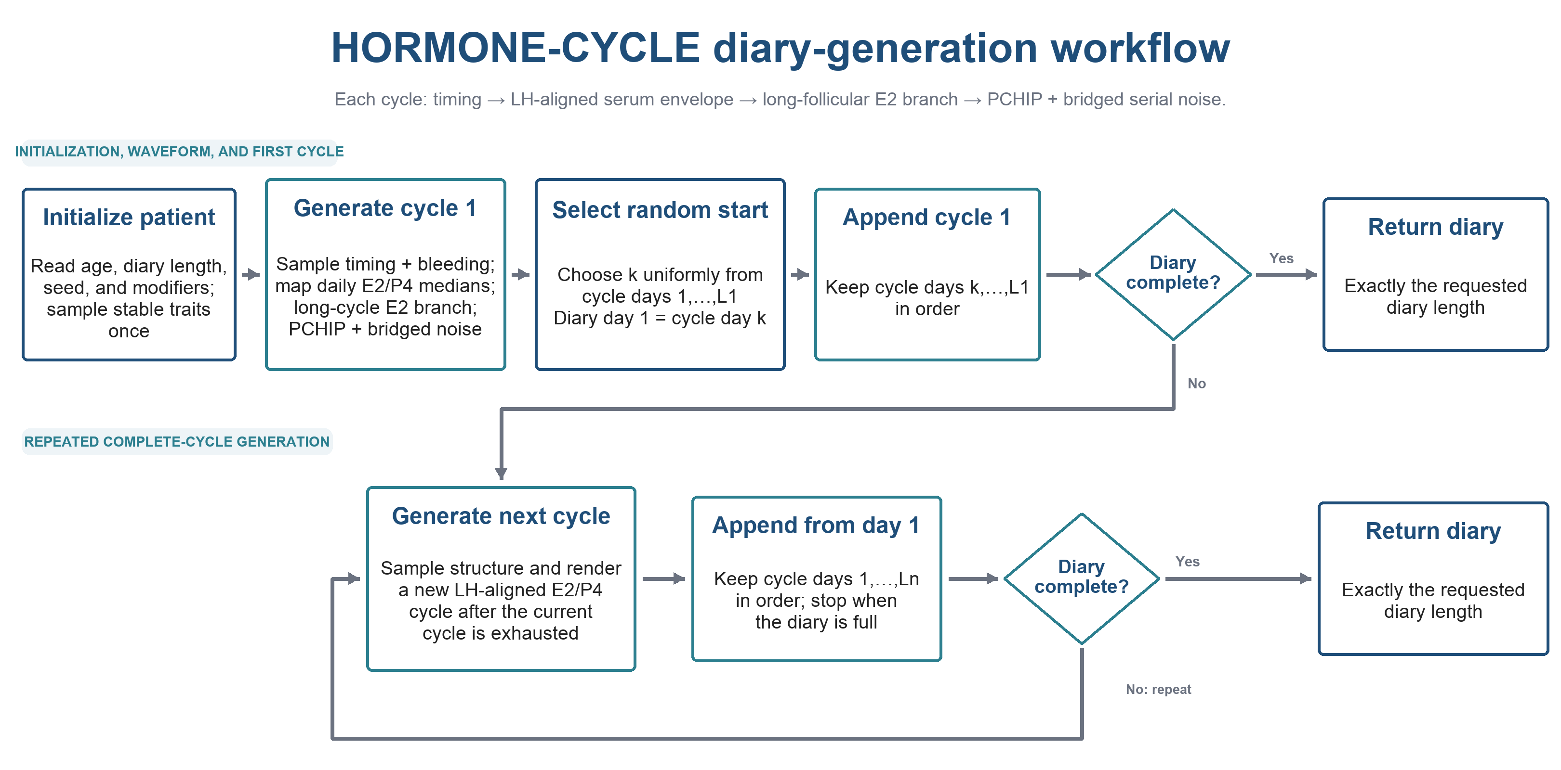
Appendix Figure A1. HORMONE-CYCLE diary-generation workflow. Each generated cycle samples structure and bleeding, maps every in-cycle LH-aligned daily serum value to the realized cycle while preserving one-day spacing through LH+7, scales only the late-luteal withdrawal tail to the endpoint, applies long-follicular E2 geometry when applicable, adds separate deterministic cycle-level timing and relative-shape variation, and then adds endpoint-bridged serial noise after PCHIP interpolation. Cycle 1 is generated in full and diary day 1 is selected uniformly from its realized days; output proceeds forward without wrapping until the requested diary length is reached.

1.3.1 Inputs and outputs
The public simulation call accepts age in years, diary length in days, a random seed, and optional reproductive or medical modifiers. Input validation rejects nonfinite ages, nonpositive diary lengths, and incompatible modifier combinations. The default start mode generates cycle 1 in full, selects one of its realized cycle days with equal probability, and assigns that day to diary day 1. The optional cycle-day-1 mode retains the original observation boundary. After the initial selection, records are retained in chronological order without wrapping. Another cycle is generated only when the retained diary remains shorter than the requested length. Records from the final generated cycle are retained only until the exact requested number of days is reached. Each daily row contains the calendar-day index, cycle index, day within cycle, realized cycle length, estradiol in picograms per milliliter, progesterone in nanograms per milliliter, ovulation, and bleeding. Cycle summaries report phase lengths, ovulation day, ovulatory status, bleeding days, reproductive stage, and active modifiers.

1.4 Age-specific patient-level parameters
Age selects one of eight calibration bands. Li et al. reported 165,668 cycles from 12,608 participants and defined an irregular participant using a mean adjacent-cycle difference of at least 7 days. Their table footnote omits ‘absolute,’ but their methods define adjacent-cycle differences as absolute values; version 0.4.0 follows that convention. The model uses their age-specific pooled within-person SD, participant irregularity prevalence, and short- and long-cycle tails; age-band means are derived from the published adjusted contrasts anchored to the reported overall mean. (5) Participant irregularity is therefore evaluated with Equation (1) rather than as the probability that any single adjacent pair crosses the threshold.
 | $$I_{i}=1\left\{\frac{1}{n_{i}-1}\sum_{j=2}^{n_{i}}{\left|L_{ij} − L_{i,j-1}\right|} ≥ 7\right\}$$ | (1)
where $I_{i}$ is the participant-level irregularity indicator, equal to one when the mean absolute adjacent-cycle difference is at least seven days and zero otherwise; $i$ is the participant index; $n_{i}$ is the number of retained cycles for participant $i$; $j$ is the ordered cycle index; $L_{ij}$ is the length in days of cycle $j$ for participant $i$; $L_{i,j-1}$ is the preceding cycle length for the same participant.
Each participant is assigned once to an age-specific low- or high-variability component. A deterministic shifted-lognormal surrogate supplied initial component probabilities and standard deviations against four AWHS outcomes per age band: pooled within-person SD, participant irregularity prevalence, and short- and long-cycle tails, using 11 cycles per participant to match the source cohort’s median follow-up. Production values were then refined and accepted against the complete simulator, which additionally represents between-person means, rounding and truncation, random observation boundaries, and variable realized follow-up. Given the resolved cycle-specific latent mean and SD, Equations (2) and (3) parameterize and sample a shifted lognormal cycle length. The 17-day shift supplies realistic right skew while the 18–120-day limits remain broad software safeguards. The ≥50-year band also includes an occasional long-cycle episode fitted to its joint targets.
 | $$τ_{ij}^{2}=ln\left[1 + {\left(\frac{s_{ij}}{m_{ij}-a}\right)}^{2}\right]$$  $$λ_{ij}=ln\left(m_{ij} − a\right)-\frac{τ_{ij}^{2}}{2}$$  $$a=17$$ | (2)
where $τ_{ij}$ is the natural-log-scale standard deviation for the shifted lognormal draw; $λ_{ij}$ is the natural-log-scale mean for the shifted lognormal draw; $s_{ij}$ is the resolved latent cycle-length standard deviation after participant component and cycle-specific modifiers; $m_{ij}$ is the resolved latent cycle-length mean after participant and cycle-specific modifiers and compensation for expected explicit shifts; $a$ is the fixed 17-day shift; $i$ is the participant index; $j$ is the cycle index.
 | $$L_{ij}=min\left(120,max\left[18,round\left\{a + exp\left(λ_{ij} + τ_{ij}Z_{ij}\right) + E_{ij}\right\}\right]\right)$$  $$Z_{ij}\sim N(0,1)$$ | (3)
where $L_{ij}$ is the realized integer cycle length in days; $Z_{ij}$ is an independent standard-normal cycle draw; $E_{ij}$ is the explicit long-cycle episode extension, zero outside the age-50-or-older episode mechanism; $a$ is the 17-day shift defined in Equation 2; $λ_{ij}$ is the log-scale mean defined in Equation 2; $τ_{ij}$ is the log-scale standard deviation defined in Equation 2; $i$ is the participant index; $j$ is the cycle index; $N$ is the normal distribution.
Stable person-level estradiol and progesterone amplitude multipliers follow lognormal distributions with coefficients of variation 0.18 and 0.22. The lognormal parameters are chosen so the multiplier has mean one.
 | $$σ_{log}=\sqrt{ln\left(1 + c^{2}\right)}$$ | (4)
where $σ_{log}$ is the standard deviation on the natural-log scale; $c$ is the requested coefficient of variation of the positive hormone-amplitude multiplier.
 | $$μ_{log}=-\frac{σ_{log}^{2}}{2}=-\frac{1}{2}ln\left(1 + c^{2}\right)$$ | (5)
where $μ_{log}$ is the mean on the natural-log scale; $σ_{log}$ is the standard deviation on the natural-log scale; $c$ is the requested coefficient of variation of the positive hormone-amplitude multiplier.
These parameter choices give the lognormal multiplier an arithmetic mean of one.
Appendix Table A2. Age-specific baseline targets. Cycle-length and irregularity values are from Li et al. (2023) (5). Ovulation probabilities are investigator-selected calibration constants implemented in HORMONE-CYCLE. The two rows below age 20 share one Li target band and differ only in the implemented ovulation probability.
Age band (years) | Mean cycle length (days) | Participants irregular: mean absolute adjacent-cycle difference ≥7 days | Baseline ovulation probability
<15 | 29.82 | 20.4% | 0.62
15–19 | 29.82 | 20.4% | 0.90
20–24 | 29.62 | 20.9% | 0.97
25–29 | 29.31 | 15.9% | 0.97
30–34 | 28.75 | 11.6% | 0.97
35–39 | 28.19 | 10.6% | 0.97
40–44 | 27.70 | 12.8% | 0.95
45–49 | 27.86 | 28.2% | 0.88
≥50 | 30.21 | 60.2% | 0.70

1.5 Cycle length, phase timing, and bleeding
For each cycle, ovulation is drawn from a Bernoulli distribution using the resolved person-level probability. Natural cycle length is drawn from the shifted lognormal process in Equations (2) and (3), rather than the former symmetric Gaussian. Ovulatory cycles use a luteal distribution centered on 12.4 days; the follicular interval absorbs most remaining cycle-length variation. Natural Cycles data reported a 29.3-day mean cycle, 16.9-day mean follicular phase, and 12.4-day mean luteal phase across 612,613 ovulatory cycles from 124,648 users. (6) The implemented latent luteal standard deviation is 3.0 days before truncation and rounding; the validation target is the published 2.4-day realized SD.
Bleeding duration is sampled around 4.0 days with a standard deviation of 1.5 days and is bounded to 0–12 days. Bull et al. reported the same 4.0 ± 1.5-day distribution in Table 1; both its mean and standard deviation are direct validation targets. The International Federation of Gynecology and Obstetrics terminology provides the clinical interpretation framework for bleeding patterns. (12) The cycle-length bounds and dispersion values are transparent calibration choices.

1.6 Daily hormone trajectories
Ovulatory trajectories in version 0.4.0 use every daily serum estradiol and progesterone median that maps inside the realized cycle from measurements in 20 healthy volunteers synchronized to the serum LH peak. (7)
For ovulatory cycles, HORMONE-CYCLE maps the complete in-cycle LH-aligned serum estradiol and progesterone medians to the simulated ovulation event, uses piecewise cubic Hermite interpolation between daily values, and preserves a broad luteal progesterone summit and the published terminal tail. Long follicular phases retain a terminal 14-day estradiol-maturation interval and use delayed-emergence or failed-wave geometry rather than stretching an ordinary-cycle template. (7,9–11) An independent assay-specific serum cohort supplies subphase amplitude and ordering checks. These comparisons concern latent population-level daily envelopes and do not establish individual clinical validity or reproduce within-day progesterone pulsatility.
The simulator places ovulation 0.75 day after the synchronized serum LH peak. Every Stricker estradiol and progesterone value whose mapped position lies within the realized cycle is used. LH-relative offsets through +7 retain their published one-day spacing; only the +7 to +14 declining tail is compressed or expanded so the +14 observation reaches the final cycle day. This avoids uniformly time-warping the postovulatory rise and peak. Local −1/0/+1-day timing perturbations are applied near the E2 and P4 peaks and taper toward the source endpoints. PCHIP, defined in Equations 6 and 7, connects the daily values without spline overshoot; Equation 8 defines the corrected LH-relative event mapping.
 | $$t=\frac{x-x_{k}}{h_{k}}$$  $$h_{00}=2t^{3}-3t^{2}+1$$  $$h_{10}=t^{3}-2t^{2}+t$$  $$h_{01}=-2t^{3}+3t^{2}$$  $$h_{11}=t^{3}-t^{2}$$ | (6)
where $t$ is the normalized position within one interpolation interval; $x$ is the requested cycle-day position; $x_{k}$ is the position of control point $k$; $h_{k}$ is the interval width $x_{k+1}-x_{k}$; $k$ is the control-point interval index; $h_{00}$ is the left-value cubic Hermite basis function; $h_{10}$ is the left-slope cubic Hermite basis function; $h_{01}$ is the right-value cubic Hermite basis function; $h_{11}$ is the right-slope cubic Hermite basis function.
 | $$y\left(x\right)=h_{00}y_{k}+h_{10}h_{k}m_{k}+h_{01}y_{k+1}+h_{11}h_{k}m_{k+1}$$  $$x_{k}≤x≤x_{k+1}$$ | (7)
where $y(x)$ is the interpolated hormone concentration at position $x$; $x$ is the requested cycle-day position; $x_{k}$ is the position of control point $k$; $x_{k+1}$ is the position of the next control point; $y_{k}$ is the hormone concentration at control point $k$; $y_{k+1}$ is the hormone concentration at the next control point; $h_{k}$ is the interval width $x_{k+1}-x_{k}$; $m_{k}$ is the shape-preserving derivative at control point $k$; $m_{k+1}$ is the shape-preserving derivative at the next control point; $h_{00}$ is the left-value basis function from Equation 6; $h_{10}$ is the left-slope basis function from Equation 6; $h_{01}$ is the right-value basis function from Equation 6; $h_{11}$ is the right-slope basis function from Equation 6; $k$ is the control-point interval index.
 | $$x(r)=\left\{\begin{matrix}o-δ+r, & r≤7, \\ o-δ+7+\left(r-7\right)\frac{L-\left(o-δ+7\right)}{7}, & 7<r≤14,\end{matrix}\right.δ=0.75$$ | (8)
where $x(r)$ is the simulated cycle-day position assigned to published LH-relative offset $r$; $r$ is the integer day relative to the synchronized serum LH peak in the Stricker daily series; $o$ is the simulated ovulation day; $δ$ is the fixed 0.75-day interval from the serum LH peak to the simulated ovulation event; $L$ is the realized cycle length in days; offsets through LH+7 retain one-day spacing, while $14$ is the final positive offset whose mapped point is the cycle endpoint.
Appendix Table A3. Complete daily ovulatory serum-hormone reference series used by HORMONE-CYCLE version 0.4.0, derived from Stricker et al. (2006) Table 1B and Figure 1. (7) Day 0 is the synchronized serum LH peak; the simulator ovulation marker is 0.75 day later. Estradiol was converted from picomoles per liter to picograms per milliliter and progesterone from nanomoles per liter to nanograms per milliliter. In the canonical 29-day cycle, LH−13 through LH+14 are the 28 observations that lie inside cycle days 1–29.
Day relative to serum LH peak | Estradiol median (pg/mL) | Progesterone median (ng/mL)
-15 | 37.99 | 0.40
-14 | 40.59 | 0.40
-13 | 37.49 | 0.30
-12 | 34.99 | 0.20
-11 | 35.49 | 0.20
-10 | 39.54 | 0.20
-9 | 41.99 | 0.20
-8 | 44.34 | 0.15
-7 | 53.44 | 0.20
-6 | 58.58 | 0.10
-5 | 71.43 | 0.15
-4 | 98.92 | 0.20
-3 | 132.31 | 0.10
-2 | 177.35 | 0.20
-1 | 255.88 | 0.30
+0 | 182.80 | 0.80
+1 | 85.23 | 1.55
+2 | 70.98 | 4.00
+3 | 87.98 | 6.45
+4 | 109.92 | 9.70
+5 | 122.77 | 10.70
+6 | 132.56 | 11.10
+7 | 150.31 | 13.35
+8 | 133.81 | 11.65
+9 | 137.16 | 10.20
+10 | 134.96 | 10.30
+11 | 92.73 | 4.55
+12 | 85.68 | 4.10
+13 | 46.34 | 1.65
+14 | 41.19 | 1.30

Long follicular phases are not created by horizontally stretching the ordinary estradiol curve. When the realized follicular interval is at least 24 days, the model keeps a 14-day terminal maturation segment aligned to ovulation and assigns extra time to a low early interval. A deterministic patient-and-cycle hash selects delayed dominant-follicle emergence by default or a failed-wave/replacement geometry in 25% of such cycles. Harlow et al. reported five heterogeneous urinary-oestrogen patterns in 28 long follicular phases, with delayed emergence most common; the implementation represents only two of those patterns. (9) Mumford et al. independently found that in cycles longer than 35 days, E2 and LH peaks occurred about three days later than in normal-length cycles, supporting delayed timing rather than proportional stretching. (10) The 25% share and failed-wave amplitude are investigator-selected heterogeneity settings, not published prevalence estimates. Equation 9 defines the start of the terminal maturation interval.
 | $$b=max\left(2,o-14\right)\text{for }o≥24$$ | (9)
where $b$ is the first cycle day of the terminal follicular estradiol-maturation interval; $o$ is the follicular length and simulated ovulation day; $14$ is the fixed terminal maturation duration in days; $24$ is the follicular-length threshold in days for the long-follicular geometry.
Anovulatory cycles use four lower-amplitude control points. Person-level hormone scales are multiplied by cycle-level lognormal amplitude scales with coefficients of variation 0.08 for estradiol and 0.10 for progesterone. A separate deterministic hash stream independently samples local estradiol and progesterone timing shifts of −1, 0, or +1 day with probabilities 0.25, 0.50, and 0.25; it also applies mean-one luteal-estradiol and progesterone-plateau shape multipliers with coefficients of variation 0.12 and 0.08. This waveform-only stream cannot change cycle length, phases, ovulation, bleeding, or downstream production random draws. Day-to-day continuity is produced by a stationary first-order autoregressive process with coefficient 0.92, and each realized noise path is linearly bridged to zero at both cycle endpoints.
 | $${\overset{\sim }{ϵ}}_{d}=ϕ{\overset{\sim }{ϵ}}_{d-1}+η_{d},η_{d}\sim N\left(0,s^{2}(1-ϕ^{2})\right)$$  $$ϕ=0.92$$  $$ϵ_{d}={\overset{\sim }{ϵ}}_{d}-\left[{\overset{\sim }{ϵ}}_{1} + \frac{d-1}{L-1}\left({\overset{\sim }{ϵ}}_{L} − {\overset{\sim }{ϵ}}_{1}\right)\right]$$ | (10)
where ${\overset{\sim }{ϵ}}_{d}$ is the unbridged fractional serial-noise state on day d; $ϵ_{d}$ is the endpoint-bridged fractional serial-noise value applied on day d; $d$ is the cycle-day index; $L$ is the realized cycle length in days; $ϕ$ is the first-order autoregressive coefficient fixed at 0.92; $η_{d}$ is the independent Gaussian innovation on day d; $s$ is the stationary standard deviation of the hormone-specific fractional noise process; $N$ is the normal distribution.
The stationary innovation scale preserves the requested marginal variance, and the linear bridge forces the fractional noise contribution to zero on the first and final cycle days. Each interpolated hormone value is multiplied by 1 + εd before the estradiol floor of 5 picograms per milliliter or progesterone floor of 0.05 nanograms per milliliter is applied.

1.7 Reproductive-stage and medical modifiers

1.7.1 Polycystic ovary syndrome
The polycystic-ovary profile lengthens cycles, increases cycle-to-cycle variation, reduces ovulation probability, and attenuates luteal progesterone. Mortimer et al. (2026) and Doi et al. supplied the initial direction-setting evidence. (13,14) Later age-stratified cycle data and intensive ultrasound and hormone sampling corroborated the implemented profile. (13,15)

1.7.2 Early postmenarche
The early-postmenarche profile lengthens cycles, increases variability, reduces ovulation, and shortens or attenuates luteal progesterone patterns. Venturoli et al. supplied the initial direction-setting evidence. (16) An adolescent multicenter study and a two-year daily hormone study later corroborated these directions. (17,18)

1.7.3 Perimenopause
The perimenopause profile increases cycle variability, lowers ovulation probability, attenuates progesterone, and increases hormone variability in accordance with menopause-transition evidence. (19) Version 0.4.0 also conditions the fitted age-50-or-older long-episode allocation on ovulatory status so intervals of at least 36 days are enriched for anovulation. Van Voorhis et al. (2008; PMID 18591314) supplies the 64.7% long-interval conditional-rate context, while O’Connor et al. (2009; PMID 19568209) supports retaining long ovulatory cycles.

1.7.4 Combined oral contraceptives
Cyclic and continuous combined oral-contraceptive profiles use fixed 28-day regimen cycles with suppressed endogenous-equivalent hormone curves. The cyclic profile generates scheduled withdrawal bleeding. The continuous profile generates amenorrhea or breakthrough bleeding. These behaviors follow the evidence summarized by Edelman et al. (20)

1.7.5 Intrauterine devices
The levonorgestrel-releasing intrauterine-device profile preserves ovulation in most cycles and reduces bleeding, with amenorrhea in a minority of cycles. Long-term hormone and ultrasound studies support these directions. (21,22) The copper intrauterine-device profile preserves ovarian cycling and increases bleeding duration. Hubacher et al. supplied contextual evidence in the initial source registry. (23) Hormone and measured-blood-loss studies later corroborated that profile. (24,25)

1.7.6 Primary dysmenorrhea
The primary-dysmenorrhea profile preserves ovulation and applies a small bleeding-duration shift. This implementation reflects the predominantly prostaglandin-mediated pain phenotype described in the clinical literature. (26)

Appendix Table A4. Core HORMONE-CYCLE parameter catalogue. The implemented rules were transcribed from src/hormone_cycler/hormone_constants.py, model.py, and types.py. The final column distinguishes direct or derived published quantities, calibrated constants, investigator choices, and software rules. Published timing and hormone anchors refer to Li et al. (2023), Bull et al. (2019), and Stricker et al. (2006) (5–7). These exact values describe version 0.4.0; Roos and menopause-transition source identifiers are given explicitly where their roles are new in this version.
Parameter | Hierarchy | Implemented rule or value | Bounds, rounding, or transformation | Evidence classification
Software/runtime | Package | HORMONE-CYCLE version 0.4.0; Python ≥3.11 | Source archive and lock file | Open-source implementation
Random-number streams | Participant and cycle | SHA-256 domain-separated Python random.Random streams for participant profile, cycle generation, and diary-start selection | Exact reproducibility for fixed inputs | Implementation choice preventing observation-boundary selection from perturbing latent profile or cycle draws
Age and stage | Participant | Age and resolved reproductive stage remain fixed for the requested diary | Age 12–<56 in calibration bands; public input is numeric | Study design and Li et al.
Participant mean cycle length | Participant | Truncated Gaussian around the age-band target after compensation for expected anovulatory and ≥50 long-cycle shifts | Between-person standard deviation 0.8 day (<20), 0.6 day (20–44), or 0.8 day (≥45); range 20–90 days | Derived and calibrated from Li et al.
Within-participant cycle standard deviation | Participant | Age-specific Bernoulli assignment to a low- or high-variability participant component; component standard deviation is stable within person | Deterministic shifted-lognormal surrogate initialization followed by full-simulator refinement against AWHS SD, irregularity, and short/long tails | Derived and calibrated from Li et al.
Natural-cycle length | Cycle | 17-day-shifted lognormal draw around the resolved person/cycle mean and variability; rounded to nearest day | 18–120 days; age ≥50 adds a 25.4912-day episode with probability 0.109 after compensating the latent mean | Bull et al. plus physiologic calibration bounds
Menopause-transition long-cycle dependence | Cycle | For fitted age-50-or-older long episodes, Bayes allocation conditions the episode on ovulatory status while preserving the marginal episode probability | Long interval threshold ≥36 days; target P(anovulatory | long)=0.647; long ovulatory cycles remain possible | Van Voorhis et al. 2008 joint-dependence target; O’Connor et al. 2009 context
Ovulation | Cycle | Bernoulli draw using the participant probability in Table A2 | Probability constrained to 0–0.99 | Investigator calibration constrained by age/stage evidence
Anovulatory cycle shift | Cycle | +1.5 days in reproductive stage; +2.5 early postmenarche; perimenopause +2.5 with probability 0.65 and −1.25 otherwise | Cycle standard deviation ×1.15 | Investigator calibration constants
Luteal duration | Cycle | Truncated Gaussian centered on 12.4 days with latent standard deviation 3.0 days; rounded to nearest day | Standard deviation 1.7 days; lower bound 9; upper bound min(17, cycle length −8) | Bull et al. plus calibration bounds
Follicular duration and ovulation day | Cycle | Cycle length minus luteal duration; ovulation day equals follicular duration | Follicular lower bound 7 days | Algorithmic consequence of the stable-luteal design
Bleeding duration | Cycle | Truncated Gaussian centered on 4.0 days with standard deviation 1.5 days; rounded to nearest day | 0–12 days | Direct Bull et al. Table 1 target; Fraser terminology
Participant hormone amplitudes | Participant | Mean-one lognormal multipliers | Coefficient of variation 0.18 for estradiol and 0.22 for progesterone | Calibration to Stricker-derived control points
Cycle hormone amplitudes | Cycle | Mean-one lognormal multipliers applied to participant scales | Coefficient of variation 0.08 for estradiol and 0.10 for progesterone | Investigator calibration constants
Cycle waveform timing | Cycle/day | Independent local E2 and P4 timing perturbations from a separate deterministic hash stream | −1, 0, or +1 day with probabilities 0.25, 0.50, and 0.25; perturbations taper away from the peak region | Roos et al. 2015 motivates nonzero heterogeneity; numerical distribution is an investigator-set anti-template guard
Cycle relative waveform shape | Cycle/day | Mean-one lognormal modulation of luteal E2 elevation and the P4 plateau | Coefficient of variation 0.12 for luteal E2 shape and 0.08 for P4 plateau shape | Roos et al. 2015 plausibility context; investigator-set anti-template guards
Ovulatory control-point positions | Cycle/day | Every in-cycle daily Stricker median is indexed to the LH peak; simulated ovulation is 0.75 day later. Offsets through LH+7 retain one-day spacing; only the LH+7 to LH+14 withdrawal tail is scaled to the realized endpoint | The published LH+14 endpoint is retained; local waveform timing shifts taper toward the source endpoints | Stricker daily series plus corrected event-alignment and late-tail mapping rule
Ovulatory hormone anchors | Cycle/day | All Stricker E2/P4 values that map inside the realized cycle; the canonical 29-day cycle uses LH−13 through LH+14 for both hormones | Converted from pmol/L and nmol/L; full in-cycle E2 coverage and LH−13 to LH−2 area fidelity are validation requirements | Direct Stricker medians after unit conversion
Long-follicular estradiol geometry | Cycle/day | For follicular phases ≥24 days, excess time precedes a fixed 14-day terminal maturation interval; deterministic profile hashing selects delayed dominant-follicle emergence or a failed-wave/replacement geometry | Failed-wave share 0.25 and failed-wave peak 0.52 × ordinary preovulatory target | Harlow qualitative morphology; Mumford independent timing context; share and amplitude are investigator-selected sensitivity settings
Anovulatory estradiol anchors | Cycle/day | 38, 86, 74, and 44 picograms per milliliter at day 1, 0.55 × cycle length, cycle end −3, and cycle end | Smooth interpolation between points | Investigator calibration constrained by anovulatory endocrine literature
Anovulatory progesterone anchors | Cycle/day | 0.35, 0.55, 0.75, and 0.40 nanograms per milliliter at the same four positions | Smooth interpolation between points | Investigator calibration constrained by anovulatory endocrine literature
Daily interpolation | Day | Shape-preserving piecewise cubic Hermite interpolation (PCHIP) using the basis and piecewise interpolation defined below | Applied separately to estradiol and progesterone without spline overshoot | Algorithmic choice
Daily serial noise | Day | Stationary first-order autoregressive state with coefficient 0.92; realized paths linearly bridged to zero at both cycle endpoints | Estradiol stationary standard deviation equals participant noise scale; progesterone uses 0.9 × that scale | Investigator smoothing/calibration choice
Hormone reporting | Day | Values rounded to two decimal places | Estradiol floor 5 picograms per milliliter; progesterone floor 0.05 nanograms per milliliter | Reporting and physiologic floor choices
Anovulatory spotting | Cycle/day | Probability 0.25 in early-postmenarche or perimenopause anovulatory cycles; begins at 0.65 × cycle length | Duration 2 days | Investigator stress-test setting
Modifier combinations | Participant | Polycystic ovary syndrome, stage, intrauterine device, and dysmenorrhea adjustments apply sequentially; oral-contraceptive settings override timing and hormone profiles | Copper and levonorgestrel intrauterine devices are mutually exclusive; oral contraceptives cannot coexist with either device | Software validation rules
Diary start and completion | Run | Generate cycle 1 in full; select its first observed day uniformly; continue forward through subsequent cycles | Optional cycle-day-1 start; no wrapping; truncate only the final retained cycle at the requested diary length | Implementation rule

Appendix Table A5. Implemented modifier values and their evidence sources. Numerical multipliers are calibration constants unless a row states a direct published quantity. Version 0.4.0’s age-50-or-older long-cycle/ovulation dependence is a core cycle rule in Table A4 rather than a multiplicative modifier; the cited papers support its conditional-rate context and direction.
Modifier | Cycle-length effect | Cycle variability | Ovulation effect | Bleeding and hormone effects | Published evidence
Polycystic ovary syndrome | Mean ×1.30 (<25 years), ×1.22 (25–34), ×1.15 (≥35) | Variability ×1.55 | Probability ×0.48 | Progesterone amplitude ×0.58; bleeding +0.4 day | Mortimer et al.; Doi et al.; Jarrett et al. (13,13–15)
Early postmenarche | Mean +2.5 days | Variability ×1.25 | Maximum probability 0.55 | Estradiol ×0.92; progesterone ×0.72; bleeding +0.5 day | Venturoli et al.; World Health Organization study; Zhang et al. (16–18)
Perimenopause | Mean unchanged | Variability ×1.35 | Probability ×0.78; fitted age-50-or-older long episodes are conditionally allocated so long intervals are enriched for anovulation | Progesterone ×0.82; bleeding +0.6 day | Santoro and Randolph (19); Van Voorhis et al. (2008; PMID 18591314) and O’Connor et al. (2009; PMID 19568209)
Copper intrauterine device | Cycle length unchanged | Cycle variability unchanged | Preserved | Bleeding +1.2 days; bleeding standard deviation +0.25 day | Hubacher et al.; Faundes et al.; Malmqvist et al. (23–25)
Levonorgestrel-releasing intrauterine device | Cycle length unchanged | Cycle variability unchanged | Maximum probability 0.82 | Bleeding −2.2 days with 0.8-day floor; amenorrhea probability 0.17 | Xiao et al.; Barbosa et al. (21,22)
Cyclic combined oral contraceptive | Fixed 28 days | Standard deviation 0.25 day | Suppressed | Mean scheduled withdrawal bleeding 4.0 days; suppressed endogenous-equivalent curves | Edelman et al. (20)
Continuous combined oral contraceptive | Fixed 28 days | Standard deviation 0.20 day | Suppressed | Amenorrhea probability 0.55; breakthrough bleeding modeled | Edelman et al. (20)
Primary dysmenorrhea | Cycle length unchanged | Cycle variability unchanged | Preserved | Bleeding +0.5 day; bleeding standard deviation +0.15 day | Dawood (26)

1.8 Reproducibility and implementation limits
Fixed inputs and a fixed seed produce identical diaries. SHA-256 domain separation creates independent profile, cycle, waveform-variation, and observation-start streams; changing the diary start rule or waveform-only heterogeneity cannot perturb latent person traits, cycle structure, ovulation, bleeding, or subsequent production draws. For computational efficiency, non-audit participants use a compact renderer that retains cycle timing, ovulation, midluteal progesterone, and inadequate-luteal-phase status while omitting unused daily concentration objects. Validation and the retained 1% audit sample use full daily curves; automated equivalence tests cover partial first/final cycles and verify that waveform changes do not alter structural draws. Reproducibility records include the repository commit, configuration, seed, diary length, age/modifiers, validation-report hash, and the executable example-selection manifest. The implementation omits pregnancy, postpartum physiology, medication changes, secular drift, missing diary entries, bleeding intensity, laboratory-assay error, mechanistic endocrine feedback, and literal intraday hormone pulses. Modifier combinations remain coarse synthetic stress tests rather than causal treatment or individual prediction models.

Chapter 2. Calibration and validation status of HORMONE-CYCLE

2.1 Evaluation terminology, source separation, and design
This chapter distinguishes fitted calibration-target reproduction, held-out aggregate cross-checks, direct waveform-construction checks, literature-informed investigator-bounded plausibility guards, visual checks, and modifier stress tests. AWHS and Bull informed cycle calibration; every in-cycle Stricker daily value constructs the ordinary ovulatory waveform; Cunningham was withheld from cycle fitting; and Anckaert was withheld from waveform construction. Harlow and Mumford informed long-follicular geometry/timing. Roos motivates nonzero timing and relative-shape heterogeneity without supplying the exact simulator bounds. Van Voorhis informs menopause-transition long-cycle/anovulation dependence, O’Connor supports retaining long ovulatory cycles, and Filicori defines the pulsatility limitation. These sources are independent only for their declared aggregate or contextual roles, not as linked person-level validation.
The quality-control design follows established simulation-study reporting principles. (3,4) The baseline command was equivalent to “hormone_cycler validate --patients 10000 --days 365 --seed 7 --start-mode random.” It restricted the baseline to ages 18–54.9 and retained 160 full diaries, 20 in each of eight age bands. Secondary modifier scenarios used 1,200 age-matched participants and paired unmodified cohorts from the same seed. Acceptance rules were encoded before execution. The run evaluated 75 calibration and waveform metrics, 14 held-out Cunningham metrics, and eight modifier scenarios. The primary gate required every one of the 89 baseline metrics to pass; modifier results remained secondary stress tests.
The AWHS age-band comparisons use equal participant weighting and at most the first 11 cycles, matching the source cohort’s median follow-up. The Cunningham cross-check uses the same simulated 12-month-equivalent summaries but retains the source study’s different age bands and estimator. AWHS’s table footnote says mean adjacent-cycle difference without specifying absolute values; because its methods define adjacent-cycle differences as absolute values, that convention was prespecified here. These design choices prevent the previous error of treating pairwise threshold exceedances as the participant-level irregularity estimand.
Before the definitive version 0.4.0 validation and paper rerun, a registry-wide provenance audit checked title, PubMed identifier, DOI, source URL, and declared evidence role for all 24 scientific-source records against PubMed. All 24 passed. The four additions document waveform heterogeneity (Roos), menopause-transition joint dependence and long ovulatory cycles (Van Voorhis and O’Connor), and progesterone pulsatility (Filicori). The machine-readable audit report is archived with the validation artifacts.

2.2 Healthy-cycle calibration targets and acceptance criteria
The AWHS calibration includes five outcomes in each of eight age bands: mean cycle length, pooled within-person SD, participant prevalence with mean absolute adjacent-cycle difference ≥7 days, cycles <24 days, and cycles >38 days. Practical margins are ±0.55 day for means; ±0.35 day for within-person SD below age 50 and ±1.0 day at age ≥50; ±3.5 percentage points for participant irregularity; and ±3 percentage points for cycle tails below age 50 and ±5 points at age ≥50. Bull checks add follicular, luteal, and bleeding means plus luteal and bleeding SDs. These margins assess aggregate similarity, not sampling confidence intervals or individual prediction.

2.3 Held-out aggregate validation and critical interpretation
Cunningham et al. reported age-specific 12-month participant means and mean participant-specific cycle-length SDs from a global Flo cohort. (8) The source was not used for fitting. Prespecified practical-equivalence margins were ±1.5 days for mean cycle length and ±1.25 days for mean personal SD, widened to ±2.5 and ±3.5 days, respectively, at ages 51–55 because the menopause-transition cohorts and estimators differ substantially.
The external summary check passed, but the interpretation is qualified. Agreement was strongest from ages 18–45. At ages 51–55, the simulator’s variability was higher than Flo but close to the much larger AWHS ≥50 residual SD. The two published cohorts therefore disagree in the region with sparse, selective, and rapidly changing cycles. The simulator retains an intermediate high-variability behavior rather than fitting the held-out source. This is a model-form uncertainty, not evidence that one cohort is correct.

2.4 Hormone waveform and phase-duration checks
Fourteen independent Anckaert hormone-amplitude/order checks compare seven estradiol and seven progesterone subphases with broad assay-aware bounds. Sixteen daily waveform checks now include complete in-cycle Stricker E2 coverage and follicular-area fidelity, preovulatory E2 width and peak timing, nonzero E2/P4 timing and relative-shape dispersion, the secondary luteal E2 peak, progesterone plateau/rise/peak timing, a guard against deterministic luteal time-warping, consecutive withdrawal, a two-sided terminal-to-peak ratio, the final within-cycle P4 drop, and cross-cycle continuity. The distributional diagnostics use 1,713 complete ovulatory cycles from 160 age-balanced retained diaries. Roos supplies the literature-based reason for nonzero heterogeneity; exact dispersion bounds are investigator-set plausibility guards. These are construction, aggregate amplitude, and morphology checks—not validation of joint individual endocrine trajectories or intraday pulses.

Appendix Table A6. Complete healthy-cycle calibration, held-out aggregate cross-check, and hormone-waveform results. The 75 calibration and waveform metrics comprise 40 AWHS age-band metrics, five Bull phase/bleeding metrics, 14 independent Anckaert amplitude/order checks, and 16 daily construction/morphology checks informed by Stricker and Roos. Calibration and construction sources are (5–7). Fourteen Cunningham metrics are held out from cycle fitting. (8) Anckaert was held out from waveform construction. Cycle and phase metrics use 10,000 adults aged 18–54.9, 365 days per participant, seed 7, randomized starting phase, equal participant weighting, and at most 11 cycles per participant. Hormone checks use 160 retained diaries (20 per age band), with distributional diagnostics over 1,713 complete ovulatory cycles. Every row passed. Direct source-fidelity checks, investigator-bounded guards, and held-out comparisons should not be conflated; the composite pass does not constitute individual-level external validation.
Metric | Simulated | Calibration target | Acceptance range | Result | Source and location | Simulation sample
Mean cycle length, age <20 | 29.85 | 29.82 | 29.27 to 30.37 | Pass | Li et al. (2023), Tables 4–5 and Supplementary Table 2 | 10,000 adults aged 18–54.9
Pooled within-person cycle-length SD, age <20 | 5.35 | 5.33 | 4.98 to 5.68 | Pass | Li et al. (2023), Tables 4–5 and Supplementary Table 2 | 10,000 adults aged 18–54.9
Participants with mean absolute adjacent difference ≥7 days, age <20 | 20.4% | 20.4% | 16.9% to 23.9% | Pass | Li et al. (2023), Tables 4–5 and Supplementary Table 2 | 10,000 adults aged 18–54.9
Cycles shorter than 24 days, age <20 | 6.5% | 7.7% | 4.7% to 10.7% | Pass | Li et al. (2023), Tables 4–5 and Supplementary Table 2 | 10,000 adults aged 18–54.9
Cycles longer than 38 days, age <20 | 6.4% | 8.3% | 5.3% to 11.3% | Pass | Li et al. (2023), Tables 4–5 and Supplementary Table 2 | 10,000 adults aged 18–54.9
Mean cycle length, age 20–24 | 29.55 | 29.62 | 29.07 to 30.17 | Pass | Li et al. (2023), Tables 4–5 and Supplementary Table 2 | 10,000 adults aged 18–54.9
Pooled within-person cycle-length SD, age 20–24 | 5.15 | 5.07 | 4.72 to 5.42 | Pass | Li et al. (2023), Tables 4–5 and Supplementary Table 2 | 10,000 adults aged 18–54.9
Participants with mean absolute adjacent difference ≥7 days, age 20–24 | 23.0% | 20.9% | 17.4% to 24.4% | Pass | Li et al. (2023), Tables 4–5 and Supplementary Table 2 | 10,000 adults aged 18–54.9
Cycles shorter than 24 days, age 20–24 | 7.5% | 7.2% | 4.2% to 10.2% | Pass | Li et al. (2023), Tables 4–5 and Supplementary Table 2 | 10,000 adults aged 18–54.9
Cycles longer than 38 days, age 20–24 | 6.2% | 6.9% | 3.9% to 9.9% | Pass | Li et al. (2023), Tables 4–5 and Supplementary Table 2 | 10,000 adults aged 18–54.9
Mean cycle length, age 25–29 | 29.34 | 29.31 | 28.76 to 29.86 | Pass | Li et al. (2023), Tables 4–5 and Supplementary Table 2 | 10,000 adults aged 18–54.9
Pooled within-person cycle-length SD, age 25–29 | 4.71 | 4.70 | 4.35 to 5.05 | Pass | Li et al. (2023), Tables 4–5 and Supplementary Table 2 | 10,000 adults aged 18–54.9
Participants with mean absolute adjacent difference ≥7 days, age 25–29 | 17.0% | 15.9% | 12.4% to 19.4% | Pass | Li et al. (2023), Tables 4–5 and Supplementary Table 2 | 10,000 adults aged 18–54.9
Cycles shorter than 24 days, age 25–29 | 6.9% | 6.1% | 3.1% to 9.1% | Pass | Li et al. (2023), Tables 4–5 and Supplementary Table 2 | 10,000 adults aged 18–54.9
Cycles longer than 38 days, age 25–29 | 4.8% | 6.2% | 3.2% to 9.2% | Pass | Li et al. (2023), Tables 4–5 and Supplementary Table 2 | 10,000 adults aged 18–54.9
Mean cycle length, age 30–34 | 28.75 | 28.75 | 28.20 to 29.30 | Pass | Li et al. (2023), Tables 4–5 and Supplementary Table 2 | 10,000 adults aged 18–54.9
Pooled within-person cycle-length SD, age 30–34 | 4.33 | 4.28 | 3.93 to 4.63 | Pass | Li et al. (2023), Tables 4–5 and Supplementary Table 2 | 10,000 adults aged 18–54.9
Participants with mean absolute adjacent difference ≥7 days, age 30–34 | 12.2% | 11.6% | 8.1% to 15.1% | Pass | Li et al. (2023), Tables 4–5 and Supplementary Table 2 | 10,000 adults aged 18–54.9
Cycles shorter than 24 days, age 30–34 | 8.0% | 6.7% | 3.7% to 9.7% | Pass | Li et al. (2023), Tables 4–5 and Supplementary Table 2 | 10,000 adults aged 18–54.9
Cycles longer than 38 days, age 30–34 | 3.4% | 4.5% | 1.5% to 7.5% | Pass | Li et al. (2023), Tables 4–5 and Supplementary Table 2 | 10,000 adults aged 18–54.9
Mean cycle length, age 35–39 | 28.22 | 28.19 | 27.64 to 28.74 | Pass | Li et al. (2023), Tables 4–5 and Supplementary Table 2 | 10,000 adults aged 18–54.9
Pooled within-person cycle-length SD, age 35–39 | 3.87 | 3.79 | 3.44 to 4.14 | Pass | Li et al. (2023), Tables 4–5 and Supplementary Table 2 | 10,000 adults aged 18–54.9
Participants with mean absolute adjacent difference ≥7 days, age 35–39 | 10.6% | 10.6% | 7.1% to 14.1% | Pass | Li et al. (2023), Tables 4–5 and Supplementary Table 2 | 10,000 adults aged 18–54.9
Cycles shorter than 24 days, age 35–39 | 8.1% | 8.1% | 5.1% to 11.1% | Pass | Li et al. (2023), Tables 4–5 and Supplementary Table 2 | 10,000 adults aged 18–54.9
Cycles longer than 38 days, age 35–39 | 2.4% | 2.9% | 0.0% to 5.9% | Pass | Li et al. (2023), Tables 4–5 and Supplementary Table 2 | 10,000 adults aged 18–54.9
Mean cycle length, age 40–44 | 27.69 | 27.70 | 27.15 to 28.25 | Pass | Li et al. (2023), Tables 4–5 and Supplementary Table 2 | 10,000 adults aged 18–54.9
Pooled within-person cycle-length SD, age 40–44 | 4.03 | 3.99 | 3.64 to 4.34 | Pass | Li et al. (2023), Tables 4–5 and Supplementary Table 2 | 10,000 adults aged 18–54.9
Participants with mean absolute adjacent difference ≥7 days, age 40–44 | 13.4% | 12.8% | 9.3% to 16.3% | Pass | Li et al. (2023), Tables 4–5 and Supplementary Table 2 | 10,000 adults aged 18–54.9
Cycles shorter than 24 days, age 40–44 | 11.2% | 11.9% | 8.9% to 14.9% | Pass | Li et al. (2023), Tables 4–5 and Supplementary Table 2 | 10,000 adults aged 18–54.9
Cycles longer than 38 days, age 40–44 | 2.6% | 2.5% | 0.0% to 5.5% | Pass | Li et al. (2023), Tables 4–5 and Supplementary Table 2 | 10,000 adults aged 18–54.9
Mean cycle length, age 45–49 | 27.96 | 27.86 | 27.31 to 28.41 | Pass | Li et al. (2023), Tables 4–5 and Supplementary Table 2 | 10,000 adults aged 18–54.9
Pooled within-person cycle-length SD, age 45–49 | 5.67 | 5.42 | 5.07 to 5.77 | Pass | Li et al. (2023), Tables 4–5 and Supplementary Table 2 | 10,000 adults aged 18–54.9
Participants with mean absolute adjacent difference ≥7 days, age 45–49 | 28.8% | 28.2% | 24.7% to 31.7% | Pass | Li et al. (2023), Tables 4–5 and Supplementary Table 2 | 10,000 adults aged 18–54.9
Cycles shorter than 24 days, age 45–49 | 17.5% | 16.0% | 13.0% to 18.9% | Pass | Li et al. (2023), Tables 4–5 and Supplementary Table 2 | 10,000 adults aged 18–54.9
Cycles longer than 38 days, age 45–49 | 4.9% | 4.2% | 1.2% to 7.2% | Pass | Li et al. (2023), Tables 4–5 and Supplementary Table 2 | 10,000 adults aged 18–54.9
Mean cycle length, age ≥50 | 30.08 | 30.21 | 29.66 to 30.76 | Pass | Li et al. (2023), Tables 4–5 and Supplementary Table 2 | 10,000 adults aged 18–54.9
Pooled within-person cycle-length SD, age ≥50 | 11.20 | 11.19 | 10.19 to 12.19 | Pass | Li et al. (2023), Tables 4–5 and Supplementary Table 2 | 10,000 adults aged 18–54.9
Participants with mean absolute adjacent difference ≥7 days, age ≥50 | 63.1% | 60.2% | 56.7% to 63.7% | Pass | Li et al. (2023), Tables 4–5 and Supplementary Table 2 | 10,000 adults aged 18–54.9
Cycles shorter than 24 days, age ≥50 | 20.3% | 18.7% | 13.7% to 23.7% | Pass | Li et al. (2023), Tables 4–5 and Supplementary Table 2 | 10,000 adults aged 18–54.9
Cycles longer than 38 days, age ≥50 | 14.9% | 14.8% | 9.8% to 19.8% | Pass | Li et al. (2023), Tables 4–5 and Supplementary Table 2 | 10,000 adults aged 18–54.9
Mean follicular interval | 16.05 | 16.90 | 15.90 to 17.90 | Pass | Bull et al. (2019), Table 1 | 10,000 adults aged 18–54.9
Mean luteal interval | 12.57 | 12.40 | 11.70 to 13.10 | Pass | Bull et al. (2019), Table 1 | 10,000 adults aged 18–54.9
Mean bleeding duration | 4.01 | 4.00 | 3.60 to 4.40 | Pass | Bull et al. (2019), Table 1 | 10,000 adults aged 18–54.9
Luteal-interval SD | 2.04 | 2.40 | 2.00 to 2.80 | Pass | Bull et al. (2019), Table 1 | 10,000 adults aged 18–54.9
Bleeding-duration SD | 1.50 | 1.50 | 1.25 to 1.75 | Pass | Bull et al. (2019), Table 1 | 10,000 adults aged 18–54.9
In-cycle Stricker estradiol reference coverage | 100.0% | 100.0% | 100.0% to 100.0% | Pass | Stricker et al. (2006), daily series; direct construction or morphology check | Canonical 29-day mapped-reference construction check
Mapped LH−13 to LH−2 estradiol area ratio (simulated/source) | 1.0000 | 1.0000 | 0.9000 to 1.1000 | Pass | Stricker et al. (2006), daily series; direct construction or morphology check | Canonical 29-day mapped-reference construction check
Estradiol, early follicular | 40.22 | 34.05 | 13.62 to 62.99 | Pass | Anckaert et al. (2021), independent assay-specific subphase reference intervals | 160 retained diaries, 20 per AWHS age band
Progesterone, early follicular | 0.34 | 0.12 | 0.05 to 0.65 | Pass | Anckaert et al. (2021), independent assay-specific subphase reference intervals | 160 retained diaries, 20 per AWHS age band
Estradiol, mid follicular | 46.27 | 46.85 | 18.74 to 86.68 | Pass | Anckaert et al. (2021), independent assay-specific subphase reference intervals | 160 retained diaries, 20 per AWHS age band
Progesterone, mid follicular | 0.18 | 0.07 | 0.05 to 0.65 | Pass | Anckaert et al. (2021), independent assay-specific subphase reference intervals | 160 retained diaries, 20 per AWHS age band
Estradiol, pre ovulatory | 143.13 | 126.40 | 50.56 to 233.83 | Pass | Anckaert et al. (2021), independent assay-specific subphase reference intervals | 160 retained diaries, 20 per AWHS age band
Progesterone, pre ovulatory | 0.19 | 0.06 | 0.05 to 0.65 | Pass | Anckaert et al. (2021), independent assay-specific subphase reference intervals | 160 retained diaries, 20 per AWHS age band
Estradiol, ovulation | 102.00 | 222.56 | 89.02 to 411.73 | Pass | Anckaert et al. (2021), independent assay-specific subphase reference intervals | 160 retained diaries, 20 per AWHS age band
Progesterone, ovulation | 1.25 | 0.50 | 0.05 to 2.00 | Pass | Anckaert et al. (2021), independent assay-specific subphase reference intervals | 160 retained diaries, 20 per AWHS age band
Estradiol, early luteal | 91.71 | 106.24 | 42.49 to 196.54 | Pass | Anckaert et al. (2021), independent assay-specific subphase reference intervals | 160 retained diaries, 20 per AWHS age band
Progesterone, early luteal | 6.48 | 7.11 | 3.20 to 13.15 | Pass | Anckaert et al. (2021), independent assay-specific subphase reference intervals | 160 retained diaries, 20 per AWHS age band
Estradiol, mid luteal | 133.09 | 137.56 | 55.03 to 254.50 | Pass | Anckaert et al. (2021), independent assay-specific subphase reference intervals | 160 retained diaries, 20 per AWHS age band
Progesterone, mid luteal | 10.56 | 12.33 | 5.55 to 22.80 | Pass | Anckaert et al. (2021), independent assay-specific subphase reference intervals | 160 retained diaries, 20 per AWHS age band
Estradiol, late luteal | 66.52 | 107.87 | 43.15 to 199.56 | Pass | Anckaert et al. (2021), independent assay-specific subphase reference intervals | 160 retained diaries, 20 per AWHS age band
Progesterone, late luteal | 2.79 | 5.72 | 2.58 to 10.59 | Pass | Anckaert et al. (2021), independent assay-specific subphase reference intervals | 160 retained diaries, 20 per AWHS age band
Estradiol preovulatory peak width at ≥80% maximum | 2.00 | 3.00 | 2.00 to 5.00 | Pass | Stricker et al. (2006), daily series; direct construction or morphology check | 1,713 complete ovulatory cycles from 160 retained diaries
Estradiol peak offset from ovulation | -2.00 | -2.00 | -3.00 to -1.00 | Pass | Roos et al. (2015; PMID 26018113); literature-informed plausibility guard | 1,713 complete ovulatory cycles from 160 retained diaries
Estradiol peak-offset SD | 0.707 | 1.000 | 0.450 to 2.500 | Pass | Roos et al. (2015; PMID 26018113); literature-informed plausibility guard | 1,713 complete ovulatory cycles from 160 retained diaries
Luteal estradiol peak / preovulatory maximum | 0.5977 | 0.5900 | 0.3500 to 0.8000 | Pass | Stricker et al. (2006), daily series; direct construction or morphology check | 1,713 complete ovulatory cycles from 160 retained diaries
Luteal/preovulatory estradiol peak-ratio SD | 0.0608 | 0.0800 | 0.0300 to 0.3000 | Pass | Roos et al. (2015; PMID 26018113); literature-informed plausibility guard | 1,713 complete ovulatory cycles from 160 retained diaries
Progesterone plateau width at ≥75% maximum | 6.00 | 6.00 | 3.00 to 9.00 | Pass | Stricker et al. (2006), daily series; direct construction or morphology check | 1,713 complete ovulatory cycles from 160 retained diaries
Progesterone peak offset from ovulation | 6.00 | 6.00 | 3.00 to 9.00 | Pass | Stricker et al. (2006), daily series; direct construction or morphology check | 1,713 complete ovulatory cycles from 160 retained diaries
Progesterone peak-offset SD | 0.699 | 1.000 | 0.450 to 2.500 | Pass | Roos et al. (2015; PMID 26018113); literature-informed plausibility guard | 1,713 complete ovulatory cycles from 160 retained diaries
Correlation: luteal length vs progesterone peak offset | 0.0511 | 0.0000 | -0.7500 to 0.7500 | Pass | Roos et al. (2015; PMID 26018113); literature-informed plausibility guard | 1,713 complete ovulatory cycles from 160 retained diaries
Progesterone ≥5 ng/mL rise offset from ovulation | 2.00 | 2.00 | 1.00 to 4.00 | Pass | Stricker et al. (2006), daily series; direct construction or morphology check | 1,713 complete ovulatory cycles from 160 retained diaries
Consecutive progesterone-decline transitions before bleeding | 6.00 | 4.00 | 3.00 to 8.00 | Pass | Stricker et al. (2006), daily series; direct construction or morphology check | 1,713 complete ovulatory cycles from 160 retained diaries
Final-cycle progesterone / cycle maximum | 0.0997 | 0.1000 | 0.0500 to 0.1800 | Pass | Stricker et al. (2006), daily series; direct construction or morphology check | 1,713 complete ovulatory cycles from 160 retained diaries
Final within-cycle progesterone drop | 0.50 | 0.40 | 0.00 to 1.00 | Pass | Stricker et al. (2006), daily series; direct construction or morphology check | 1,713 complete ovulatory cycles from 160 retained diaries
Progesterone jump across cycle boundary | 0.81 | 0.00 | 0.00 to 1.00 | Pass | Stricker et al. (2006), daily series; direct construction or morphology check | 1,713 complete ovulatory cycles from 160 retained diaries
Held-out mean cycle length, age 18–25 | 29.66 | 28.99 | 27.49 to 30.49 | Pass | Cunningham et al. (2024), held-out aggregate cross-check | 10,000 adults aged 18–54.9; first 11 cycles per participant
Held-out mean participant-specific SD, age 18–25 | 4.78 | 4.14 | 2.89 to 5.39 | Pass | Cunningham et al. (2024), held-out aggregate cross-check | 10,000 adults aged 18–54.9; first 11 cycles per participant
Held-out mean cycle length, age 26–30 | 29.24 | 28.76 | 27.26 to 30.26 | Pass | Cunningham et al. (2024), held-out aggregate cross-check | 10,000 adults aged 18–54.9; first 11 cycles per participant
Held-out mean participant-specific SD, age 26–30 | 4.19 | 3.95 | 2.70 to 5.20 | Pass | Cunningham et al. (2024), held-out aggregate cross-check | 10,000 adults aged 18–54.9; first 11 cycles per participant
Held-out mean cycle length, age 31–35 | 28.66 | 28.28 | 26.78 to 29.78 | Pass | Cunningham et al. (2024), held-out aggregate cross-check | 10,000 adults aged 18–54.9; first 11 cycles per participant
Held-out mean participant-specific SD, age 31–35 | 3.75 | 3.80 | 2.55 to 5.05 | Pass | Cunningham et al. (2024), held-out aggregate cross-check | 10,000 adults aged 18–54.9; first 11 cycles per participant
Held-out mean cycle length, age 36–40 | 28.11 | 27.68 | 26.18 to 29.18 | Pass | Cunningham et al. (2024), held-out aggregate cross-check | 10,000 adults aged 18–54.9; first 11 cycles per participant
Held-out mean participant-specific SD, age 36–40 | 3.00 | 3.72 | 2.47 to 4.97 | Pass | Cunningham et al. (2024), held-out aggregate cross-check | 10,000 adults aged 18–54.9; first 11 cycles per participant
Held-out mean cycle length, age 41–45 | 27.71 | 27.18 | 25.68 to 28.68 | Pass | Cunningham et al. (2024), held-out aggregate cross-check | 10,000 adults aged 18–54.9; first 11 cycles per participant
Held-out mean participant-specific SD, age 41–45 | 3.34 | 3.92 | 2.67 to 5.17 | Pass | Cunningham et al. (2024), held-out aggregate cross-check | 10,000 adults aged 18–54.9; first 11 cycles per participant
Held-out mean cycle length, age 46–50 | 28.45 | 27.15 | 25.65 to 28.65 | Pass | Cunningham et al. (2024), held-out aggregate cross-check | 10,000 adults aged 18–54.9; first 11 cycles per participant
Held-out mean participant-specific SD, age 46–50 | 5.44 | 4.72 | 3.47 to 5.97 | Pass | Cunningham et al. (2024), held-out aggregate cross-check | 10,000 adults aged 18–54.9; first 11 cycles per participant
Held-out mean cycle length, age 51–55 | 30.04 | 28.00 | 25.50 to 30.50 | Pass | Cunningham et al. (2024), held-out aggregate cross-check | 10,000 adults aged 18–54.9; first 11 cycles per participant
Held-out mean participant-specific SD, age 51–55 | 9.88 | 6.52 | 3.02 to 10.02 | Pass | Cunningham et al. (2024), held-out aggregate cross-check | 10,000 adults aged 18–54.9; first 11 cycles per participant

2.5 Age-matched modifier software stress tests
Each modifier was simulated separately with 1,200 participants and compared with an unmodified cohort generated from the same seed and age range. PCOS, oral-contraceptive, intrauterine-device, and dysmenorrhea scenarios used ages 18–44.9; perimenopause used ages 45–54.9; and peri-menarche used ages 13–17.9. Version 0.4.0 adds two perimenopause joint-dependence checks: the anovulatory fraction among intervals ≥36 days and a positive material long-versus-ordinary anovulation contrast. The papers generally support effect direction, broad ranges, or a conditional-rate context; exact numerical margins remain investigator-selected regression guards. These are age-matched software stress tests, not held-out clinical validation.
Appendix Table A7. Secondary age-matched modifier stress-test summary. Each scenario uses 1,200 participants and an unmodified cohort generated with the same seed and age range. “Code-defined checks” counts the criteria listed in Table A8. Exact margins are investigator-selected regression guards; passing indicates behavior in the declared direction/range, not clinical validity. Polycystic ovary syndrome is compared with Mortimer et al. (2026) and Jarrett et al. (2020) (13,15). Early postmenarche is compared with the World Health Organization study (1986) and Zhang et al. (2008) (17,18). Perimenopause is compared with Santoro and Randolph (2011) (19); Van Voorhis et al. (2008; PMID 18591314) and O’Connor et al. (2009; PMID 19568209) supply long-interval joint-dependence context. Combined oral contraceptives are compared with Edelman et al. (2014) (20). The levonorgestrel-releasing intrauterine device is compared with Xiao et al. (1995) and Barbosa et al. (1995) (21,22). The copper intrauterine device is compared with Faundes et al. (1980) and Malmqvist et al. (1974) (24,25). Primary dysmenorrhea is compared with Dawood (2006) (26).
Scenario | Mean cycle (days) | Ovulatory cycles | Mean bleeding (days) | Irregularity | Amenorrhea | Code-defined checks
Polycystic ovary syndrome (ages 18–44.9) | 35.77 | 46.5% | 4.40 | 56.1% | 0.2% | 3/3 passed
Cyclic combined oral contraceptive (ages 18–44.9) | 28.00 | 0.0% | 3.99 | 0.0% | 0.0% | 2/2 passed
Continuous combined oral contraceptive (ages 18–44.9) | 28.00 | 0.0% | 0.96 | 0.0% | 55.0% | 3/3 passed
Levonorgestrel-releasing intrauterine device (ages 18–44.9) | 29.00 | 81.5% | 1.68 | 14.9% | 24.0% | 2/2 passed
Copper intrauterine device (ages 18–44.9) | 28.77 | 96.2% | 5.20 | 13.3% | 0.2% | 2/2 passed
Perimenopause (ages 45–54.9) | 29.54 | 48.3% | 5.23 | 54.6% | 0.2% | 4/4 passed
Early postmenarche (ages 13–17.9) | 33.37 | 53.9% | 5.13 | 47.6% | 0.2% | 3/3 passed
Primary dysmenorrhea (ages 18–44.9) | 28.82 | 96.2% | 4.51 | 15.6% | 0.5% | 2/2 passed

Appendix Table A8. Auditable secondary modifier stress-test criteria. Each scenario uses 1,200 participants and a seed- and age-matched unmodified cohort. Acceptance bounds were defined in the validation code and are investigator-selected unless the criterion names a direct published quantity. The supporting papers are named in the source column; they generally support directions or broad ranges rather than the exact numerical bounds.
Scenario | Code-defined criterion | Simulated value | Acceptance range | Supporting paper | Result
Polycystic ovary syndrome | Direction-only check: PCOS should shift mean cycle length upward versus its age-matched baseline. | 35.77 days | 30.75 days to 999.00 days | Mortimer et al. 2026 | Pass
Polycystic ovary syndrome | Direction-only check: PCOS should increase cycle irregularity versus its age-matched baseline. | 56.1% | 21.6% to 100.0% | Mortimer et al. 2026 | Pass
Polycystic ovary syndrome | Direction-only check: PCOS should reduce ovulation frequency versus its age-matched baseline. | 46.5% | 0.0% to 77.9% | Doi et al. 2005 | Pass
Cyclic combined oral contraceptive | 21/7 combined OCPs should suppress ovulation. | 0.0% | 0.0% to 2.0% | Edelman et al. 2014 | Pass
Cyclic combined oral contraceptive | 21/7 regimens should preserve scheduled withdrawal bleeding. | 3.99 days | 3.00 days to 5.00 days | Edelman et al. 2014 | Pass
Continuous combined oral contraceptive | Continuous combined OCPs should suppress ovulation. | 0.0% | 0.0% to 2.0% | Edelman et al. 2014 | Pass
Continuous combined oral contraceptive | Continuous use should reduce bleeding days relative to cyclic use. | 0.96 days | 0.00 days to 2.50 days | Edelman et al. 2014 | Pass
Continuous combined oral contraceptive | Continuous use should produce substantial amenorrhea/infrequent bleeding. | 55.0% | 40.0% to 90.0% | Edelman et al. 2014 | Pass
Levonorgestrel-releasing intrauterine device | Long-term LNG-IUD users should remain ovulatory in most cycles. | 81.5% | 70.0% to 90.0% | Xiao et al. 1995 | Pass
Levonorgestrel-releasing intrauterine device | Amenorrhea should occur in a minority but not rare fraction of LNG-IUD cycles. | 24.0% | 10.0% to 25.0% | Xiao et al. 1995 | Pass
Copper intrauterine device | Direction-only check: copper IUDs should not materially suppress ovulation versus an age-matched baseline. | 96.2% | 91.2% to 101.2% | Faundes et al. 1980 | Pass
Copper intrauterine device | Direction-only check: copper IUDs should increase bleeding duration versus an age-matched baseline. | 5.20 days | 4.51 days to 6.01 days | Malmqvist et al. 1974 | Pass
Perimenopause | Direction-only check: perimenopause should increase cycle irregularity. | 54.6% | 25.0% to 100.0% | Santoro and Randolph 2011 | Pass
Perimenopause | Direction/range check: perimenopause should reduce ovulation frequency. | 48.3% | 45.0% to 80.0% | Santoro and Randolph 2011 | Pass
Perimenopause | Direct published-context check: Van Voorhis reported 64.7% anovulation among intervals of at least 36 days; the broad interval allows cohort and simulator differences. | 61.6% | 45.0% to 80.0% | Van Voorhis et al. 2008 | Pass
Perimenopause | Direction/range check: Van Voorhis reported 64.7% anovulation in ≥36-day versus 8.1% in 21–35-day intervals. The exact contrast is context, not a fitted target, because stage mixtures differ. | 11.6% | 5.0% to 80.0% | Van Voorhis et al. 2008 | Pass
Early postmenarche | Direction/range check: early post-menarche cycles should be longer on average. | 33.37 days | 30.00 days to 40.00 days | WHO Task Force 1986 | Pass
Early postmenarche | Direction-only check: early post-menarche cycles should be more irregular. | 47.6% | 28.0% to 100.0% | WHO Task Force 1986 | Pass
Early postmenarche | Direction/range check: adolescents with irregular menses should be frequently anovulatory; this is not a universal perimenarche estimate. | 53.9% | 30.0% to 60.0% | Venturoli et al. 1986 | Pass
Primary dysmenorrhea | Direction-only check: primary dysmenorrhea should preserve ovulation versus an age-matched baseline. | 96.2% | 88.2% to 104.2% | Dawood 2006 | Pass
Primary dysmenorrhea | Investigator-bounded check: dysmenorrhea should only mildly shift bleeding duration versus an age-matched baseline. | 4.51 days | 4.21 days to 5.21 days | Dawood 2006 | Pass

2.6 Graphical calibration summary and representative traces
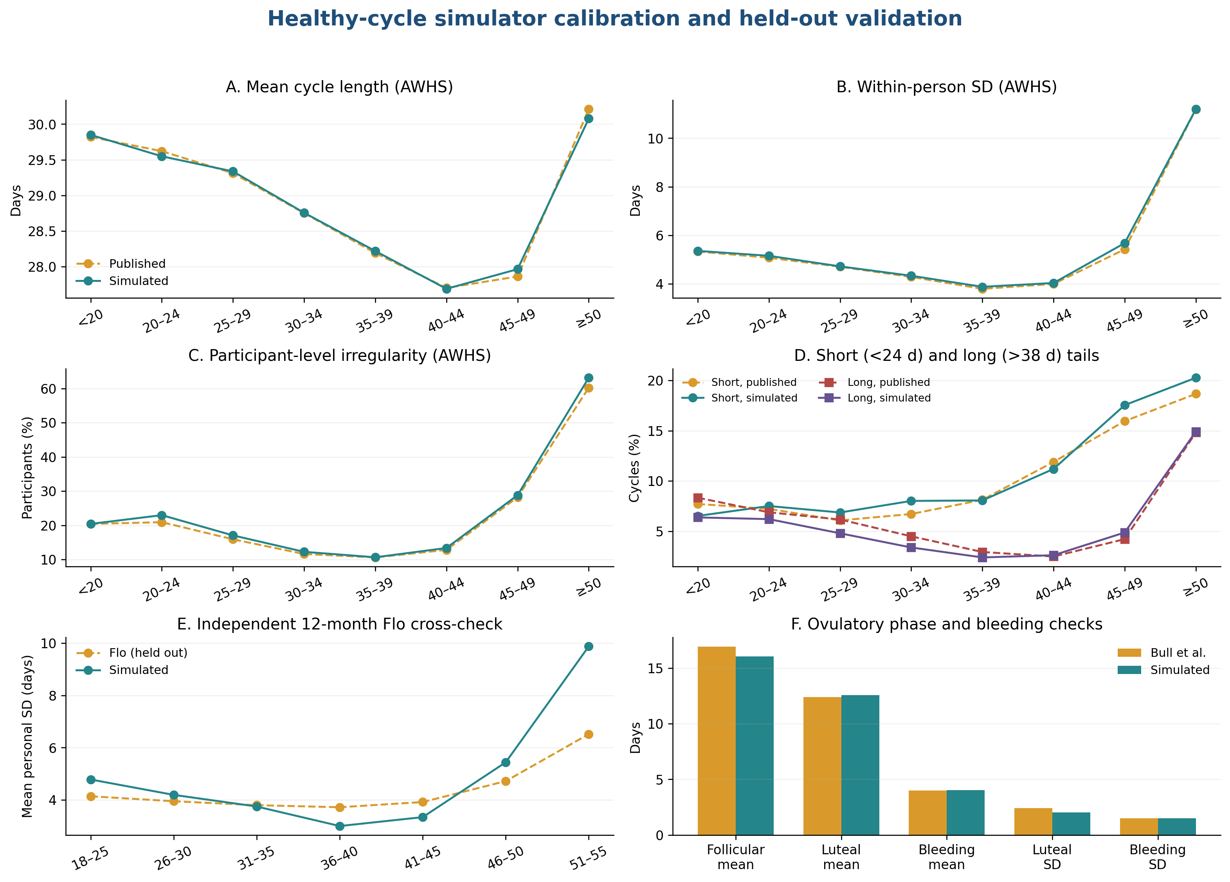
Appendix Figure A2. Healthy-cycle calibration and held-out aggregate validation. Panels A–D compare simulated age-specific mean cycle length, pooled within-person SD, participant irregularity, and short/long tails with AWHS. Panel F compares follicular, luteal, and bleeding means and SDs with Bull et al. Calibration sources are (5–7) Panel E compares mean participant-specific SD with the held-out Cunningham Flo cohort. (8) Published and simulated lines are aggregate summaries; the older-age discrepancy in panel E is retained as model-form uncertainty.
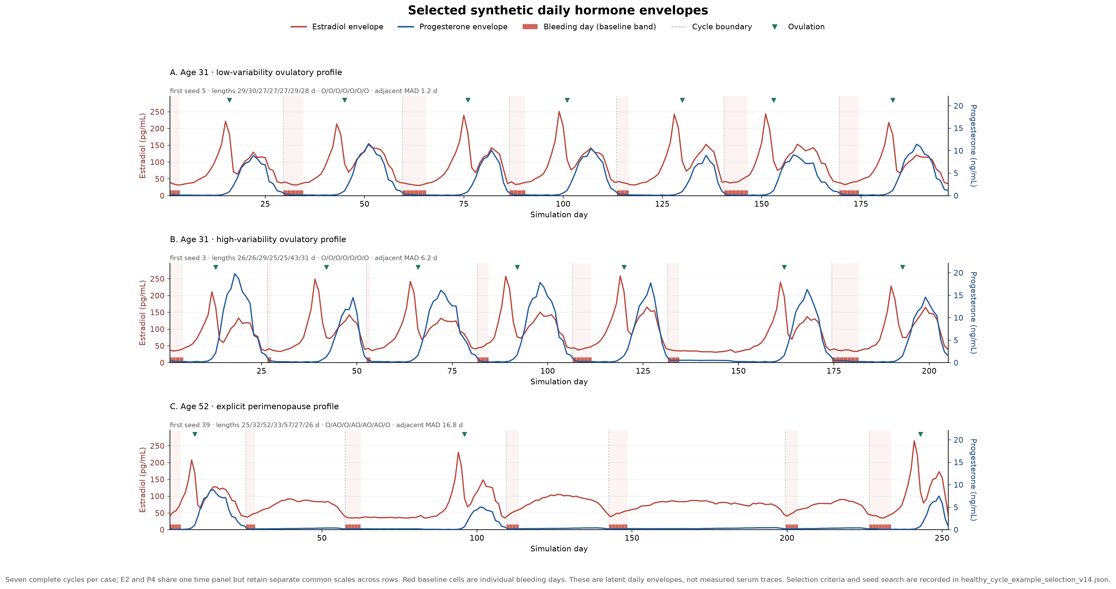
Appendix Figure A3. Selected synthetic latent daily hormone envelopes after the HORMONE-CYCLE version 0.4.0 update. Each row is one unified time plot with estradiol and progesterone overlaid using hormone-specific dual axes and common hormone-specific scales across rows. Individual bleeding days are shown explicitly as red baseline cells, and green triangles mark ovulation. Panels A and B show the first seven complete cycles from selected low- and high-variability age-31 ovulatory profiles. Panel C uses an explicit age-52 perimenopause modifier and includes ordinary, long ovulatory, and long anovulatory cycles. The first seed meeting each executable criterion was retained from an ascending 0–5000 search; criteria, seed, stage, cycle lengths, and ovulatory states are archived in the selection manifest. The examples illustrate model behavior and are not independent validation observations.
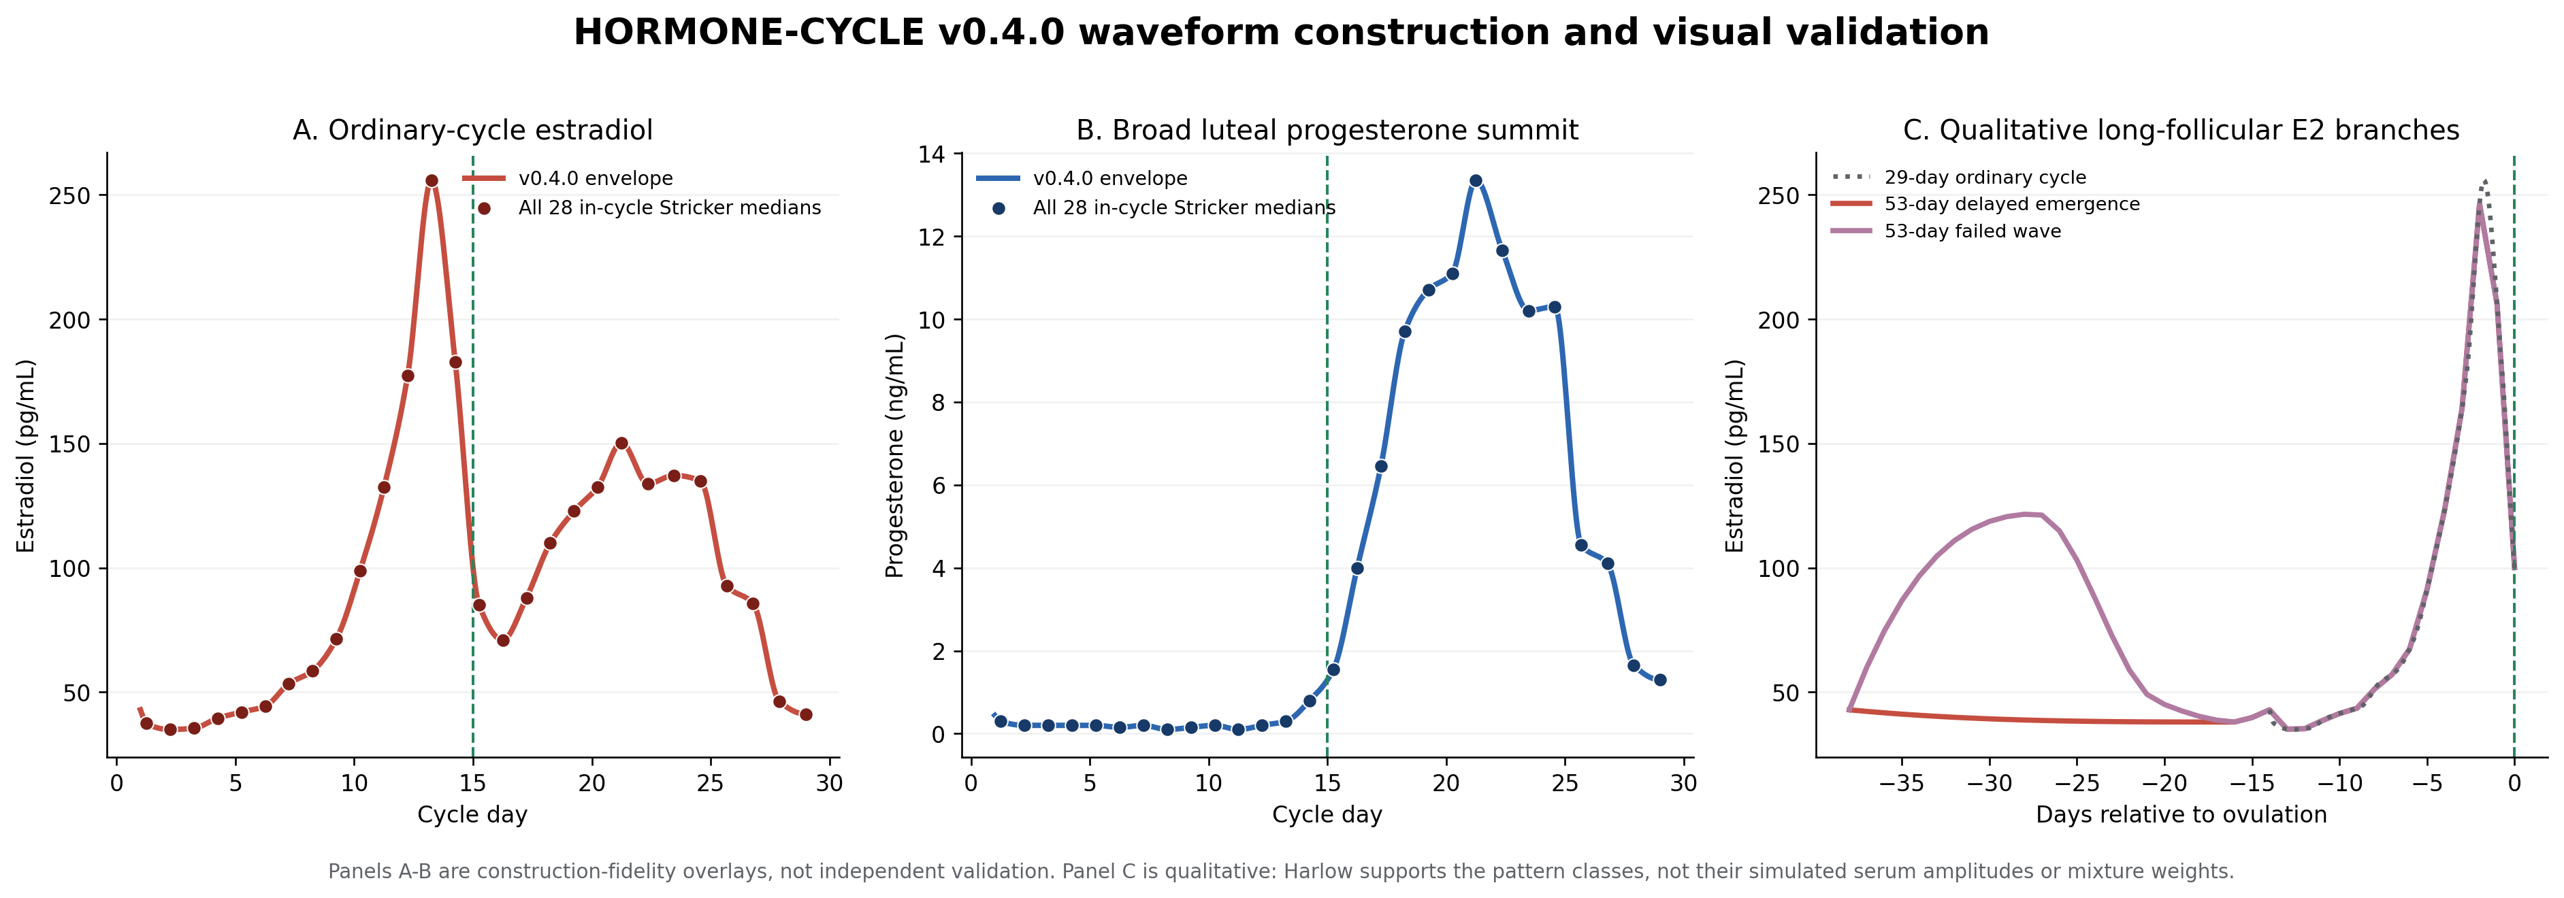
Appendix Figure A4. HORMONE-CYCLE version 0.4.0 waveform construction and visual source-fidelity check. Panels A and B overlay the canonical ordinary-cycle estradiol and progesterone envelopes on all 28 Stricker daily medians that map within cycle days 1–29. (7) The vertical dashed line is the simulated ovulation day, 0.75 day after the synchronized LH peak. The corrected E2 envelope includes the previously omitted early/mid-follicular observations; offsets through LH+7 retain one-day spacing and only the late withdrawal tail is scaled. Panel C compares an ordinary follicular E2 segment with two Harlow-informed 53-day-cycle geometries. (9) Excess follicular time precedes a fixed 14-day terminal maturation interval; the failed-wave option and its 25% share remain investigator-selected sensitivity settings. This figure checks construction and morphology, not participant-level clinical validity.
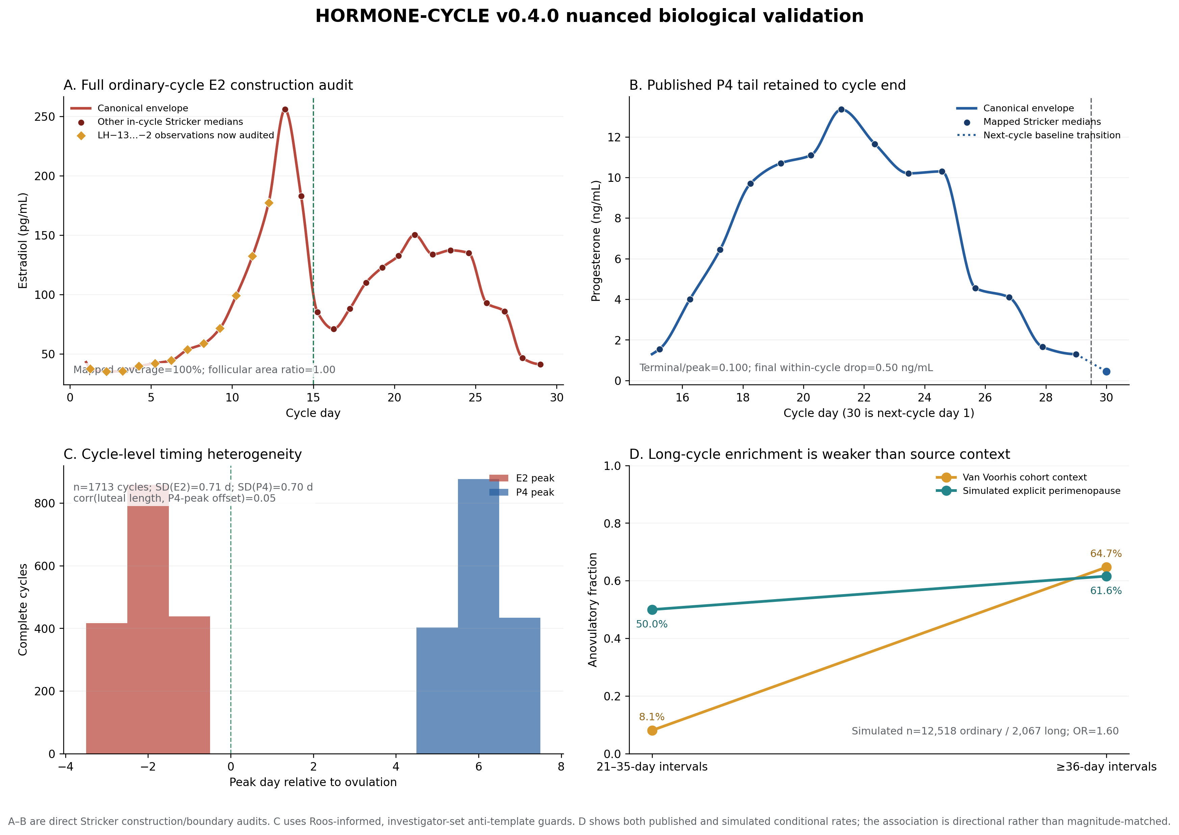
Appendix Figure A5. Nuanced HORMONE-CYCLE version 0.4.0 construction and plausibility checks added after critical audit. Panel A shows 100% coverage of in-cycle Stricker E2 observations and a simulated/source LH−13 to LH−2 follicular area ratio of 1.00. Panel B shows a median terminal/peak P4 ratio of 0.100 and median final within-cycle drop of 0.50 ng/mL. Panel C summarizes 1,713 complete ovulatory cycles: E2- and P4-peak timing SDs were 0.71 and 0.70 days, and the luteal-length/P4-peak-offset correlation was 0.05. Panel D shows the explicit perimenopause scenario: 61.6% of ≥36-day intervals and 50.0% of ordinary 21–35-day intervals were anovulatory (odds ratio 1.60), alongside the Van Voorhis et al. (2008; PMID 18591314) context of 64.7% and 8.1%. Stricker supplies direct construction constraints; Roos et al. (2015; PMID 26018113) supplies the reason for nonzero timing/shape dispersion, but the exact dispersion bounds are investigator-set. All displayed gates passed; none is individual-level external validation.

2.7 Validation conclusion and remaining needs
The primary gate is a qualified pass: version 0.4.0 passed all 89 baseline checks, including 75 calibration/waveform metrics and 14 held-out Cunningham checks, plus all eight modifier scenarios. Every in-cycle Stricker E2 observation is now used and follicular area fidelity is exact in the canonical construction; median E2 peak width at ≥80% of maximum is two days, within the prespecified two-to-five-day daily-envelope range. Peak timing is no longer cloned, whole-luteal time-warping has been removed, and the published terminal P4 tail is retained. The explicit perimenopause scenario produced 61.6% anovulation among ≥36-day intervals, but 50.0% among ordinary intervals, so its long-cycle association is directionally correct but much weaker than the source contrast. Long-follicular E2 still implements only two of Harlow’s five patterns, and its mixture is not prevalence-calibrated. The output remains a smooth latent daily envelope that omits intraday pulsatility and literal individual serum variation. Independent linked daily bleeding, ovulation, and hormone records remain necessary for person-level external validation.
A dedicated post-change critical review found no mission-critical defect for the intended catamenial-epilepsy null-distribution use and therefore did not recommend another simulator loop. It judged the corrected follicular E2 construction, nonzero timing dispersion, removal of whole-luteal time warping, preserved terminal P4 source value, explicitly staged age-52 example, auditable seed selection, and directionally enriched long-cycle anovulation sufficient for biologically plausible null histories.
Material limitations remain and are disclosed: short luteal phases can compress P4 withdrawal; the perimenopause joint association is weaker than published; timing heterogeneity is a discrete investigator-set perturbation around one population-median template; Anckaert bounds are broad; condition-specific daily endocrine distributions and combined-factor stacking are less directly validated; older-age cycle dispersion remains source-sensitive; and long-follicular E2 classes and mixture weights remain coarse. These issues do not invalidate the null generator because E2 does not define the paper’s classification and P4 affects the analysis only through inadequate-luteal-phase/C3 eligibility, which was regenerated in the full version 0.4.0 study run.

Chapter 3. Additional analyses and methods augmenting the main results
This chapter documents how HORMONE-CYCLE and the seizure-diary simulator were combined for the present false-positive study. It then reports the phase algorithms, ratio and regression methods, sensitivity analyses, and supplementary results.

3.1 Reproducibility, provenance, and simulator inputs
The completed primary simulation included 100,000 synthetic participants, 50,000 per cohort, followed for 36 months with master seed 20260505. HORMONE-CYCLE generated menstrual and hormone diaries. (1) The Cyclic Heterogeneous Overdispersed Clustered Open-source L-relationship Adjustable Temporally limited E-diary Simulator (CHOCOLATES) generated seizure diaries. The generators were run independently. HORMONE-CYCLE selected diary day 1 uniformly from the realized days of the first generated menstrual cycle and then continued forward without wrapping. The diaries were merged by calendar-day index. (2) Direct alignment preserved the original day ordering throughout the merge.
The reporting framework follows simulation-study guidance. (3,4) CHOCOLATES and HORMONE-CYCLE were designed to reproduce selected statistical features within and across synthetic patient populations through data-informed hierarchical sampling. Chapter 1 details the HORMONE-CYCLE evidence sources and transformations.
The completed manifest stores the analysis-code fingerprint 01897437f6815e3e64d086c19b790a3e03527a761e0ed6f3bd947121ceafdb2e and configuration fingerprint aba1bfbeef1cc391d2de5558fb962c28bf720d8e68906b32d034ed707890515d. These Secure Hash Algorithm 256-bit fingerprints identify the exact v14 analysis code and configuration used for the completed run.

Appendix Table S1. Simulator inputs, realized features, and evidence roles for the completed study. Literature sources are named in the source/rationale column; investigator-configured values are study assumptions. The named HORMONE-CYCLE, CHOCOLATES, seizure-rhythm, menstrual-cycle, and Herzog sources are cited here (1,2,5–7,27,28). “Simulator-native” means drawn directly by CHOCOLATES. “Multidien” denotes periods longer than 24 hours. “Audit spectrum” is a spectral estimate from retained daily audit data. “Interseizure constraints” are generator limits on simulated intervals between seizures. Hormone concentrations are written in nanograms per milliliter or picograms per milliliter.
Domain | Parameter | Cohort | Setting / sampling distribution | Level | Source / rationale | Realized target
Seizure | Monthly burden | Both | Simulator-native empirical distribution | Participant | Goldenholz & Westover 2023 | Realized seizures/month
Seizure | Overdispersion | Both | Simulator-native | Participant/day | Goldenholz & Westover 2023 | Audit daily variance/mean
Seizure | Clustering | Both | Simulator-native | Participant/day | Goldenholz & Westover 2023 | Audit next-day clustering proxy
Seizure | Multidien periods and amplitudes | Both | Simulator-native | Participant/day | Goldenholz & Westover 2023; Karoly et al. | Generator period and audit spectrum
Seizure | Interseizure constraints | Both | Simulator-native | Day | Goldenholz & Westover 2023 | Not separately stored
Menstrual | Age | Cohort-specific | {'healthy_ovulatory': {'age_range': [18.0, 45.0], 'force_ovulatory_cycles': True}, 'population': {'age_range': [13.0, 54.9], 'force_ovulatory_cycles': False}} | Participant | Investigator-configured study cohorts | Participant age
Menstrual | Cycle length and variability | Both | Age-specific low/high participant-variability mixture initialized by a deterministic surrogate and refined in the full simulator; 17-day-shifted lognormal cycle sampler; broad 18–120-day software bounds | Participant/cycle | Calibrated to Li et al. 2023; Cunningham et al. 2024 held out | Age-specific mean, pooled within-person SD, participant irregularity, short/long tails, and held-out 12-month cross-check
Menstrual | Bleeding duration | Both | Literature-calibrated | Cycle | Bull et al. 2019 | Available in simulator validation suite
Menstrual | Ovulation and phase timing | Cohort-specific | Age/stage/modifier-dependent | Participant/cycle | Bull et al. 2019; simulator literature registry | Ovulatory fraction
Menstrual | Hormone trajectories | Both | LH-aligned daily Stricker medians mapped to ovulation with PCHIP; terminal follicular maturation is not stretched in long cycles; deterministic delayed-emergence or failed-wave E2 geometry | Cycle/day | Stricker et al. 2006; Harlow et al. 2000; Mumford et al. 2012 | Independent Anckaert subphase amplitudes plus prespecified daily morphology checks
Menstrual | ILP rule | Population | Maximum P4 on O+5 to O+9 < 5.0 ng/mL; nonovulatory/missing cycles flagged | Cycle | Investigator operationalization; threshold requires biological citation | Audit ILP fraction
Menstrual | PCOS | Population | 0.1 | Participant | Investigator-configured stress-test rate | Participant prevalence
Menstrual | Peri-menarche | Population | 0.6 | Participant conditional on age <20 | Investigator-configured stress-test rate | Participant prevalence
Menstrual | Perimenopause | Population | 0.55 | Participant conditional on age ≥45 | Investigator-configured stress-test rate | Participant prevalence
Menstrual | Dysmenorrhea | Population | 0.12 | Participant | Investigator-configured stress-test rate | Not retained in participant summary
Menstrual | Contraception/IUD settings | Both | Available but not sampled in completed run | Participant | Simulator literature registry | Not applicable to completed run
Computational | Compact hormone rendering | Non-audit participants | Consumes the same cycle RNG draws as the full renderer and retains identical cycle structure, ovulation, midluteal progesterone, and ILP status while omitting unused daily concentration objects; full curves retained for validation and the 1% audit sample | Participant/cycle | Result-preserving implementation optimization with automated full-versus-compact equivalence tests | Structural and ILP equivalence; full hormone values in retained audit rows
Observation | Diary duration and start | Both | 36 months; diary day 1 sampled uniformly within the first generated menstrual cycle | Participant | Study design | 36 months with randomized starting phase
Observation | Missingness | Both | No diary missingness simulated | Day | Study-design simplification | Complete synthetic diaries
Null construction | Independent generators | Both | Separately seeded generators; HORMONE-CYCLE uses SHA-256-separated profile, cycle, and observation-start streams, starts at a uniformly sampled first-cycle day, and aligns directly without wrapping | Participant | Study design | Direct alignment and randomized menstrual starting phase preserved without changing latent profile/cycle draws
Null construction | Master seed | Both | 20260505 | Run | Reproducibility control | Manifested
Null construction | Phase modes | Both | strict_herzog, luteal_anchored_ovulatory | Analysis | Herzog criteria plus sensitivity | Both modes retained
Null construction | Cohort sizes | Cohort-specific | {'healthy_ovulatory': 50000, 'population': 50000} | Run | Monte Carlo design | 100,000 total

3.2 Assumption-by-assumption review
Within this section, menstrual (M), follicular (F), ovulatory (O), and luteal (L) identify cycle phases. Type C1 is the perimenstrual pattern, type C2 is the periovulatory pattern, and type C3 is the inadequate-luteal-phase pattern. Inadequate luteal phase (ILP) is the operational designation defined in Section 3.4.
Appendix Table S2. Assumptions, rationale, and implications for interpretation. The Herzog ratio definitions, thresholds, and inadequate-luteal-phase context derive from Herzog and colleagues (28,29).
Assumption | Rationale | Limitation / implication
Independent generators | Defines the false-positive estimand through independent seizure and hormone random streams. | True catamenial effects and false negatives fall outside this null simulation.
Direct calendar-day alignment | Preserves the separately seeded seizure and hormone outputs while HORMONE-CYCLE selects a uniformly random first-cycle start day. | No end-to-start wraparound is introduced; boundary exposure is randomized across menstrual phases.
36-month diaries | Provides long follow-up and permits shorter nested window comparisons. | Medication changes and secular trends fall outside the data-generating model.
Healthy ovulatory cohort | Provides a lower-heterogeneity reference in which C3 is not applicable. | This reference cohort represents ovulatory menstrual cycling under the configured age range.
Heterogeneous cohort | Stress-tests irregularity, anovulation, and configured modifiers. | Configured modifier rates serve as stress-test inputs; population prevalence estimation falls outside scope.
Strict Herzog phases | Preserves historical comparability with the original criteria. | The ovulatory interval expands in longer cycles; the luteal-anchored mode tests a fixed interval.
Unlabeled days | Matches the historical phase partition and prevents implicit reassignment. | Reduces observed denominators and can make short windows indeterminate.
Exact thresholds 1.69/1.83/1.62 | Uses the published distributional inflection points as the implemented thresholds. | Threshold performance remains dependent on sparse numerator and comparator counts.
Zero-comparator handling | Reports a positive numerator over a zero comparator as +infinity and reports 0/0 as undefined. | Makes the sparse-event vulnerability transparent rather than silently adding a continuity correction.
Inadequate-luteal-phase threshold <5 ng/mL | Operationalizes the ovulatory threshold used in the original Herzog phase study. | The cutoff captures one operational definition of luteal adequacy.
Nonovulatory cycles designated inadequate luteal phase | Matches the implemented C3 adapter and the C3 concept of inadequate luteal-phase cycles. | Type C3 sensitivity depends directly on the simulated prevalence of anovulation.
Minimum-data rule | Investigator-selected sensitivity to reduce classifications dominated by very sparse seizure counts. | The four-month or six-cycle and four-seizure-day cutoffs are pragmatic sensitivity settings.
Negative-binomial type C1/type C2 calibration | Checks rejection behavior with a model family concordant with the CHOCOLATES count process. | This analysis is a statistical calibration check for the simulator-based study.
Exploratory negative-binomial type C3 | Provides a separately specified follicular-versus-combined-phase contrast in ILP cycles. | Uses only the saved 1% daily audit sample and stricter eligibility.
Randomized diary boundary | Diary day 1 is selected uniformly from the realized days of the first generated menstrual cycle, after which generation proceeds forward. | The first and final observed cycles may be partial; analyses requiring complete cycles exclude them.
Stationary treatment and background risk | Keeps the null stationary and interpretable. | Limits transportability to clinical diaries with treatment changes or disease evolution.

3.3 Menstrual-phase labeling and complete-cycle rules
Phase labels were assigned to each complete menstrual cycle before any analysis-window subset was taken. Forward day counts from menstrual onset, with day 1 as the first bleeding day. Backward day equals the forward day minus the cycle length plus one, so the final cycle day is −1. Label priority is menstrual, follicular, ovulatory, and then luteal. Days outside the listed ranges remain unlabeled in the strict definition.
Appendix Table S3. Implemented strict Herzog and luteal-anchored sensitivity phase boundaries. Forward day is counted from menstrual onset and backward day from the next onset. Priority rules prevent overlapping labels. The luteal-anchored definition fixes the ovulatory interval immediately before the luteal phase and assigns the remaining nonmenstrual days to the follicular phase.
Phase | Strict Herzog definition | Luteal-anchored sensitivity
Menstrual (M) | Forward days 1–3 or backward days −3 to −1 | Same
Follicular (F) | Forward days 4–9 | All days not assigned to M, O, or L
Ovulatory (O) | Forward day ≥10 and backward day ≤−13 | Backward days −16 to −13
Luteal (L) | Backward days −12 to −4 | Backward days −12 to −4
Unlabeled | All remaining days | None

A complete cycle contains every daily row from cycle day 1 through its recorded cycle length. The exact three-cycle Herzog analysis additionally requires three complete cycles, each 23–35 days long. For combined phases, average daily seizure frequency is calculated as the total seizure count across all included phases divided by the total number of labeled days across those phases.

3.4 Type C3 and inadequate-luteal-phase algorithm
Type C3 is the inadequate-luteal-phase catamenial pattern. The present adapter is a custom operationalization. Herzog et al. used a single day-22 progesterone measurement and a 5-nanogram-per-milliliter threshold. (28) This study borrowed that threshold and defined the timing and aggregation algorithm separately.
The adapter designates a nonovulatory cycle or a cycle without a valid ovulation day as inadequate. For an ovulatory cycle, it takes the maximum progesterone concentration from days 5–9 after ovulation. If the interval reaches the diary boundary, it uses the available postovulation days. A maximum below 5 nanograms per milliliter is designated inadequate. A maximum of exactly 5 is therefore adequate in the implemented rule. Complete HORMONE-CYCLE daily outputs contain progesterone on every simulated day. The adapter also contains a defensive missing-field branch that designates the cycle inadequate; that branch was never exercised in this completed simulation and should be treated as an implementation limitation.
Type C3 applicability is evaluated within each analysis window. A pooled window is applicable when it contains at least one designated cycle. The completed study evaluated type C3 only in the heterogeneous cohort as a study-design applicability rule. The healthy cohort was omitted from type C3 reporting; enforced ovulation does not establish that low luteal progesterone is biologically impossible.

3.5 Herzog seizure-frequency ratios and thresholds
Average daily seizure frequency (ADSF) is the number of seizures in a phase divided by the number of labeled days in that phase. Menstrual (M), follicular (F), ovulatory (O), and luteal (L) denote the locally defined phases. The three ratios are shown in Equations (11)–(13). The exact thresholds 1.69, 1.83, and 1.62 correspond to published distributional inflection points. (28,29)
 | $$C_{1}=\frac{ADSF(M)}{ADSF(F+L)}$$ | (11)
where $C_{1}$ is the perimenstrual Herzog ratio; $ADSF$ is average daily seizure frequency over the phase set in parentheses; $M$ is menstrual-phase days; $F$ is follicular-phase days; $L$ is luteal-phase days.
 | $$C_{2}=\frac{ADSF(O)}{ADSF(F+L)}$$ | (12)
where $C_{2}$ is the periovulatory Herzog ratio; $ADSF$ is average daily seizure frequency over the phase set in parentheses; $O$ is ovulatory-phase days; $F$ is follicular-phase days; $L$ is luteal-phase days.
 | $$C_{3}=\frac{ADSF(O+L+M)}{ADSF(F)}$$ | (13)
where $C_{3}$ is the inadequate-luteal-phase Herzog ratio; $ADSF$ is average daily seizure frequency over the phase set in parentheses; $O$ is ovulatory-phase days; $L$ is luteal-phase days; $M$ is menstrual-phase days; $F$ is follicular-phase days.
A small comparator count can produce a large or undefined ratio. Positive infinity is defined and exceeds every finite threshold. Ratios of zero divided by zero and ratios with missing phase days are undefined.
The exact three-cycle analysis requires exactly three complete 23–35-day cycles and classifies a participant when at least two cycles are positive. (30)
Appendix Table S4. Cumulative distributions of Herzog seizure-frequency ratios in strict three-complete-cycle windows. Panels A–C show simulations; Panel A also shows the NIH Progesterone Trial baseline C1 distribution (n=294) reported by Herzog (2015). Ratio definitions originate from Herzog et al. (1997) (28,29). Simulation denominators at threshold zero include finite and positive-infinite ratios and exclude undefined ratios; the Herzog column uses all 294 participants. Simulation denominators are below 50,000 because zero-over-zero ratios, missing phase days, and eligibility failures are undefined or unavailable. Positive infinity is included at every applicable threshold.

Panel A — Type C1
Herzog ratio threshold (≥) | Healthy n | Healthy % | Heterogeneous n | Heterogeneous % | Herzog 2015, %  (n=294) (29)
0 | 43,579 | 100.00 | 43,586 | 100.00 | 100.00
1 | 19,691 | 45.18 | 19,605 | 44.98 | 66.67
1.69 | 11,943 | 27.41 | 11,890 | 27.28 | 38.10
2 | 10,740 | 24.64 | 10,729 | 24.62 | 34.35
3 | 6,110 | 14.02 | 6,109 | 14.02 | 21.43
4 | 4,695 | 10.77 | 4,734 | 10.86 | 17.35
5 | 3,380 | 7.76 | 3,472 | 7.97 | 14.97
6 | 3,128 | 7.18 | 3,198 | 7.34 | 12.24
7 | 2,915 | 6.69 | 2,984 | 6.85 | 10.54
8 | 2,526 | 5.80 | 2,597 | 5.96 | 8.16
9 | 2,436 | 5.59 | 2,518 | 5.78 | 7.48
10 | 2,269 | 5.21 | 2,348 | 5.39 | 6.46

Panel B — Type C2
Herzog ratio threshold (≥) | Healthy n | Healthy % | Heterogeneous n | Heterogeneous %
0 | 43,958 | 100.00 | 44,034 | 100.00
1 | 19,966 | 45.42 | 20,515 | 46.59
1.83 | 11,480 | 26.12 | 11,664 | 26.49
2 | 10,423 | 23.71 | 10,635 | 24.15
3 | 6,571 | 14.95 | 6,776 | 15.39
4 | 4,826 | 10.98 | 5,101 | 11.58
5 | 3,911 | 8.90 | 4,178 | 9.49
6 | 3,446 | 7.84 | 3,699 | 8.40
7 | 3,102 | 7.06 | 3,382 | 7.68
8 | 2,921 | 6.64 | 3,153 | 7.16
9 | 2,814 | 6.40 | 3,033 | 6.89
10 | 2,709 | 6.16 | 2,923 | 6.64

Panel C — Type C3
Herzog ratio threshold (≥) | Heterogeneous n | Heterogeneous %
0 | 16,322 | 100.00
1 | 10,183 | 62.39
1.62 | 8,714 | 53.39
2 | 8,252 | 50.56
3 | 7,658 | 46.92
4 | 7,419 | 45.45
5 | 7,286 | 44.64
6 | 7,213 | 44.19
7 | 7,173 | 43.95
8 | 7,145 | 43.78
9 | 7,115 | 43.59
10 | 7,097 | 43.48

Panel D — Sparse-comparator audit
Ratio | Cohort | Finite | Positive infinity | Undefined | At or above threshold | Positive-infinite share
Type C1 | Healthy ovulatory | 41,602 | 1,977 | 6,421 | 11,943 | 1,977 (16.6%)
Type C1 | Heterogeneous | 41,563 | 2,023 | 6,414 | 11,890 | 2,023 (17.0%)
Type C2 | Healthy ovulatory | 41,601 | 2,357 | 6,042 | 11,480 | 2,357 (20.5%)
Type C2 | Heterogeneous | 41,458 | 2,576 | 5,966 | 11,664 | 2,576 (22.1%)
Type C3 | Heterogeneous | 9,322 | 7,000 | 3,437 | 8,714 | 7,000 (80.3%)

Panel D audits pooled ratio status in the same strict three-cycle data used for panels A–C. The final exact Herzog classification separately requires at least two of three individual cycles to be positive. “Positive-infinite share” is the number of positive-infinite ratios divided by all pooled ratios at or above the applicable threshold.

3.6 Type C3 window-duration sensitivity
Type C3 is the inadequate-luteal-phase pattern. This sensitivity analysis varies the amount of observation available for that pattern.
Appendix Table S5. Windowed type C3 false-positive classifications in the heterogeneous cohort. All 50,000 heterogeneous-cohort participants were attempted. “Applicable” indicates at least one designated inadequate-luteal-phase cycle in the window. “Classifiable” additionally requires a defined ratio. “All-attempted rate” is positive divided by 50,000. The healthy ovulatory cohort was omitted under the study-design applicability rule described in Section 3.4.
Window | Applicable | Classifiable | Positive | Positive among classifiable, % (95% Wilson confidence interval) | All-attempted rate
1 month | 16,193 | 7,636 | 4,406 | 57.7% (56.6%–58.8%) | 8.8%
3 months | 22,180 | 16,141 | 8,648 | 53.6% (52.8%–54.3%) | 17.3%
4 months | 24,189 | 18,710 | 9,711 | 51.9% (51.2%–52.6%) | 19.4%
6 months | 26,768 | 21,874 | 10,690 | 48.9% (48.2%–49.5%) | 21.4%
9 months | 29,732 | 25,283 | 11,683 | 46.2% (45.6%–46.8%) | 23.4%
12 months | 32,174 | 27,724 | 12,175 | 43.9% (43.3%–44.5%) | 24.3%
18 months | 35,931 | 31,420 | 12,979 | 41.3% (40.8%–41.9%) | 26.0%
24 months | 38,889 | 34,372 | 13,542 | 39.4% (38.9%–39.9%) | 27.1%
36 months | 43,766 | 38,583 | 14,293 | 37.0% (36.6%–37.5%) | 28.6%
3 complete cycles | 19,759 | 16,322 | 8,714 | 53.4% (52.6%–54.2%) | 17.4%
6 complete cycles | 25,321 | 21,804 | 10,443 | 47.9% (47.2%–48.6%) | 20.9%
12 complete cycles | 31,085 | 27,490 | 11,811 | 43.0% (42.4%–43.6%) | 23.6%
36 months | 43,766 | 38,583 | 14,293 | 37.0% (36.6%–37.5%) | 28.6%

3.7 Investigator-selected minimum-data sensitivity
The minimum-data thresholds are investigator-selected sensitivity settings. They represent the minimum amount of seizure information an investigator is willing to accept before classification. The analysis reports every setting; investigators select the sensitivity appropriate to their scientific question.
Appendix Table S6. Classification across observation windows and minimum seizure-day requirements. Each cohort contains 50,000 attempted participants. “Positive among classifiable” is positive divided by classifiable with a 95% Wilson score confidence interval. “All-attempted rate” is positive divided by 50,000 (31).
Cohort | Window | Minimum seizure days | Classifiable | Positive | Positive among classifiable, % (95% Wilson confidence interval) | All-attempted rate
Healthy ovulatory | 4 months | 2 | 43,188 | 16,441 | 38.1% (37.6%–38.5%) | 32.9%
Healthy ovulatory | 6 months | 2 | 45,261 | 15,050 | 33.3% (32.8%–33.7%) | 30.1%
Healthy ovulatory | 12 months | 2 | 47,522 | 11,586 | 24.4% (24.0%–24.8%) | 23.2%
Healthy ovulatory | 36 months | 2 | 49,193 | 5,454 | 11.1% (10.8%–11.4%) | 10.9%
Heterogeneous | 4 months | 2 | 43,102 | 16,428 | 38.1% (37.7%–38.6%) | 32.9%
Heterogeneous | 6 months | 2 | 45,198 | 15,418 | 34.1% (33.7%–34.6%) | 30.8%
Heterogeneous | 12 months | 2 | 47,510 | 11,784 | 24.8% (24.4%–25.2%) | 23.6%
Heterogeneous | 36 months | 2 | 49,168 | 5,531 | 11.2% (11.0%–11.5%) | 11.1%
Healthy ovulatory | 4 months | 3 | 40,269 | 14,719 | 36.6% (36.1%–37.0%) | 29.4%
Healthy ovulatory | 6 months | 3 | 43,129 | 13,745 | 31.9% (31.4%–32.3%) | 27.5%
Healthy ovulatory | 12 months | 3 | 46,362 | 10,891 | 23.5% (23.1%–23.9%) | 21.8%
Healthy ovulatory | 36 months | 3 | 48,777 | 5,201 | 10.7% (10.4%–10.9%) | 10.4%
Heterogeneous | 4 months | 3 | 40,158 | 14,788 | 36.8% (36.4%–37.3%) | 29.6%
Heterogeneous | 6 months | 3 | 43,147 | 14,248 | 33.0% (32.6%–33.5%) | 28.5%
Heterogeneous | 12 months | 3 | 46,394 | 11,130 | 24.0% (23.6%–24.4%) | 22.3%
Heterogeneous | 36 months | 3 | 48,763 | 5,270 | 10.8% (10.5%–11.1%) | 10.5%
Healthy ovulatory | 4 months | 4 | 37,627 | 13,437 | 35.7% (35.2%–36.2%) | 26.9%
Healthy ovulatory | 6 months | 4 | 41,140 | 12,805 | 31.1% (30.7%–31.6%) | 25.6%
Healthy ovulatory | 12 months | 4 | 45,268 | 10,394 | 23.0% (22.6%–23.4%) | 20.8%
Healthy ovulatory | 36 months | 4 | 48,359 | 4,993 | 10.3% (10.1%–10.6%) | 10.0%
Heterogeneous | 4 months | 4 | 37,366 | 13,449 | 36.0% (35.5%–36.5%) | 26.9%
Heterogeneous | 6 months | 4 | 41,163 | 13,266 | 32.2% (31.8%–32.7%) | 26.5%
Heterogeneous | 12 months | 4 | 45,278 | 10,562 | 23.3% (22.9%–23.7%) | 21.1%
Heterogeneous | 36 months | 4 | 48,333 | 5,070 | 10.5% (10.2%–10.8%) | 10.1%
Healthy ovulatory | 4 months | 6 | 32,717 | 11,325 | 34.6% (34.1%–35.1%) | 22.7%
Healthy ovulatory | 6 months | 6 | 37,514 | 11,228 | 29.9% (29.5%–30.4%) | 22.5%
Healthy ovulatory | 12 months | 6 | 43,128 | 9,475 | 22.0% (21.6%–22.4%) | 18.9%
Healthy ovulatory | 36 months | 6 | 47,556 | 4,630 | 9.7% (9.5%–10.0%) | 9.3%
Heterogeneous | 4 months | 6 | 32,624 | 11,361 | 34.8% (34.3%–35.3%) | 22.7%
Heterogeneous | 6 months | 6 | 37,492 | 11,651 | 31.1% (30.6%–31.5%) | 23.3%
Heterogeneous | 12 months | 6 | 43,131 | 9,605 | 22.3% (21.9%–22.7%) | 19.2%
Heterogeneous | 36 months | 6 | 47,503 | 4,745 | 10.0% (9.7%–10.3%) | 9.5%

3.8 Model-concordant negative-binomial calibration checks
The primary model-concordant calibration check uses a log-link negative-binomial generalized linear model for daily seizure counts. Participant-full-diary method-of-moments dispersion is used, with cycle fixed effects when the required complete cycles are available. Type C1 and type C2 one-sided Wald tests are adjusted by the Holm method within participant. (32) Type C1 is the perimenstrual contrast, type C2 is the periovulatory contrast, and type C3 is the inadequate-luteal-phase contrast. The Cyclic Heterogeneous Overdispersed Clustered Open-source L-relationship Adjustable Temporally limited E-diary Simulator (CHOCOLATES) uses an overdispersed count process. (2) Concordance is limited to the count family and log link. The regression does not reproduce CHOCOLATES clustering, multidien rhythms, or participant heterogeneity. The indicator IM equals 1 on menstrual days, the indicator IO equals 1 on ovulatory days, and both equal 0 otherwise.
 | $$log(μ_{icd})=β_{0}+β_{M}I_{M,icd}+β_{O}I_{O,icd}+γ_{c}$$ | (14)
where $μ_{icd}$ is the expected seizure count for participant i, cycle c, and day d; $i$ is the participant index; $c$ is the cycle index; $d$ is the day index; $β_{0}$ is the intercept; $β_{M}$ is the menstrual-phase log rate-ratio coefficient; $β_{O}$ is the ovulatory-phase log rate-ratio coefficient; $I_{M,icd}$ is the menstrual-phase indicator; $I_{O,icd}$ is the ovulatory-phase indicator; $γ_{c}$ is the fixed effect for cycle $c$.
Follicular and luteal days form the reference category because both phase indicators equal 0 on those days.
The exploratory type C3 model restricts the data to complete simulator-designated inadequate-luteal-phase cycles and replaces the two phase indicators with one indicator for combined ovulatory, luteal, and menstrual days. Positivity requires a one-sided P value below .05 and a rate ratio of at least 1.62. The minimum data are four complete designated cycles and four seizure days. A robust Poisson model with heteroskedasticity-consistent covariance type 0 is attempted only when the negative-binomial fit raises an exception. Both models use a maximum of 100 iterations. Each daily row has one day of exposure, so no offset is required.Equation (15) defines the participant-specific negative-binomial dispersion.
 | $$α_{i}=\left\{\begin{matrix}1, & {\overline{y}}_{i}≤0 or s_{i}^{2}≤{\overline{y}}_{i}, \\ max\left({10}^{-6},min\left(50 , \frac{s_{i}^{2}-{\overline{y}}_{i}}{{\overline{y}}_{i}^{2}}\right)\right), & s_{i}^{2}>{\overline{y}}_{i}>0.\end{matrix}\right.$$ | (15)
where $α_{i}$ is the negative-binomial dispersion for participant $i$; $i$ is the participant index; ${\overline{y}}_{i}$ is the participant-specific mean daily seizure count over the full diary; $s_{i}^{2}$ is the participant-specific sample variance of daily seizure counts.
The implemented fallback sets dispersion to 1 when the mean is nonpositive or the sample variance does not exceed the mean. Otherwise, the method-of-moments estimate is bounded below by 10−6 and above by 50 for numerical stability.
Equation (16) gives the exploratory type C3 model.
 | $$log(μ_{icd})=β_{0}+β_{OLM}I_{OLM,icd}+γ_{c}$$ | (16)
where $μ_{icd}$ is the expected seizure count for participant i, cycle c, and day d; $i$ is the participant index; $c$ is the cycle index; $d$ is the day index; $β_{0}$ is the intercept; $β_{OLM}$ is the log rate-ratio coefficient comparing combined ovulatory, luteal, and menstrual days with follicular days; $I_{OLM,icd}$ is the combined ovulatory-luteal-menstrual phase indicator; $γ_{c}$ is the fixed effect for cycle $c$.
The retained daily audit sample was selected independently within each cohort without replacement at a 1% fraction. NumPy’s default random-number generator used a deterministic 32-bit seed derived from master seed 20260505, the cohort name, and “audit_sample.” The heterogeneous-cohort seed was 529110050. The type C3 exploratory analysis attempted all 500 retained heterogeneous participants: 428 had ratio-level type C3 applicability, 198 met regression data requirements, 279 had fewer than four complete inadequate-luteal-phase cycles, and 23 had fewer than four seizure days. All 198 classifiable participants used the negative-binomial fit; no robust-Poisson fallback or regression failure occurred. 13 were positive.
Appendix Table S7. Exploratory type C3 negative-binomial calibration result in the retained 1% daily audit sample. All 500 retained heterogeneous participants were attempted; 428 were ratio-applicable, 198 were regression-classifiable, and 13 were positive. “All-attempted rate” is 13/500. The 95% Wilson interval describes Monte Carlo uncertainty under this configured simulation. No robust-Poisson fallback was used.
Attempted | Ratio type C3 applicable | Negative-binomial classifiable | Positive | Positive among classifiable, % (95% Wilson confidence interval) | All-attempted rate
500 | 428 | 198 | 13 | 6.6% (3.9%–10.9%) | 2.6%

3.9 Mutually exclusive pattern decomposition
Type C1 denotes the perimenstrual pattern, type C2 the periovulatory pattern, and type C3 the inadequate-luteal-phase pattern. Table S8 separates their mutually exclusive combinations.
Appendix Table S8. Mutually exclusive participant-window categories in 36-month strict-Herzog windows. Each cohort contains 50,000 attempted participants. “Windowed Herzog” uses the full 36-month diary. “Minimum-data” adds a minimum of four seizure days. Type C3 follows the heterogeneous-cohort applicability rule. Percentages may differ from 100% by rounding.
Cohort / definition | None | Indeterminate | C1 only | C2 only | C1+C2 | C3 only | C3 with C1 and/or C2
Healthy / windowed Herzog | 87.9% | 0.8% | 5.6% | 3.4% | 2.2% | N/A | N/A
Healthy / minimum-data | 86.7% | 3.3% | 5.1% | 2.9% | 2.0% | N/A | N/A
Heterogeneous / windowed Herzog | 63.6% | 0.8% | 3.7% | 2.1% | 1.1% | 24.1% | 4.5%
Heterogeneous / minimum-data | 62.7% | 3.3% | 3.3% | 1.7% | 1.0% | 23.9% | 4.2%

3.10 Simulator-feature associations
The machine-readable file tableS4_simulated_classification_associations.csv reports stratified false-positive classification rates and 95% Wilson score confidence intervals (31) across configured quintiles of age, seizure burden, cycle length and variability, ovulatory fraction, and dominant seizure-cycle period, plus configured binary modifiers. These descriptive results apply to the synthetic study population.

3.11 Realized simulation distributions
The figures in this section show simulated data. Polycystic ovary syndrome (PCOS) and inadequate luteal phase (ILP) are written in abbreviated form within selected panel labels.
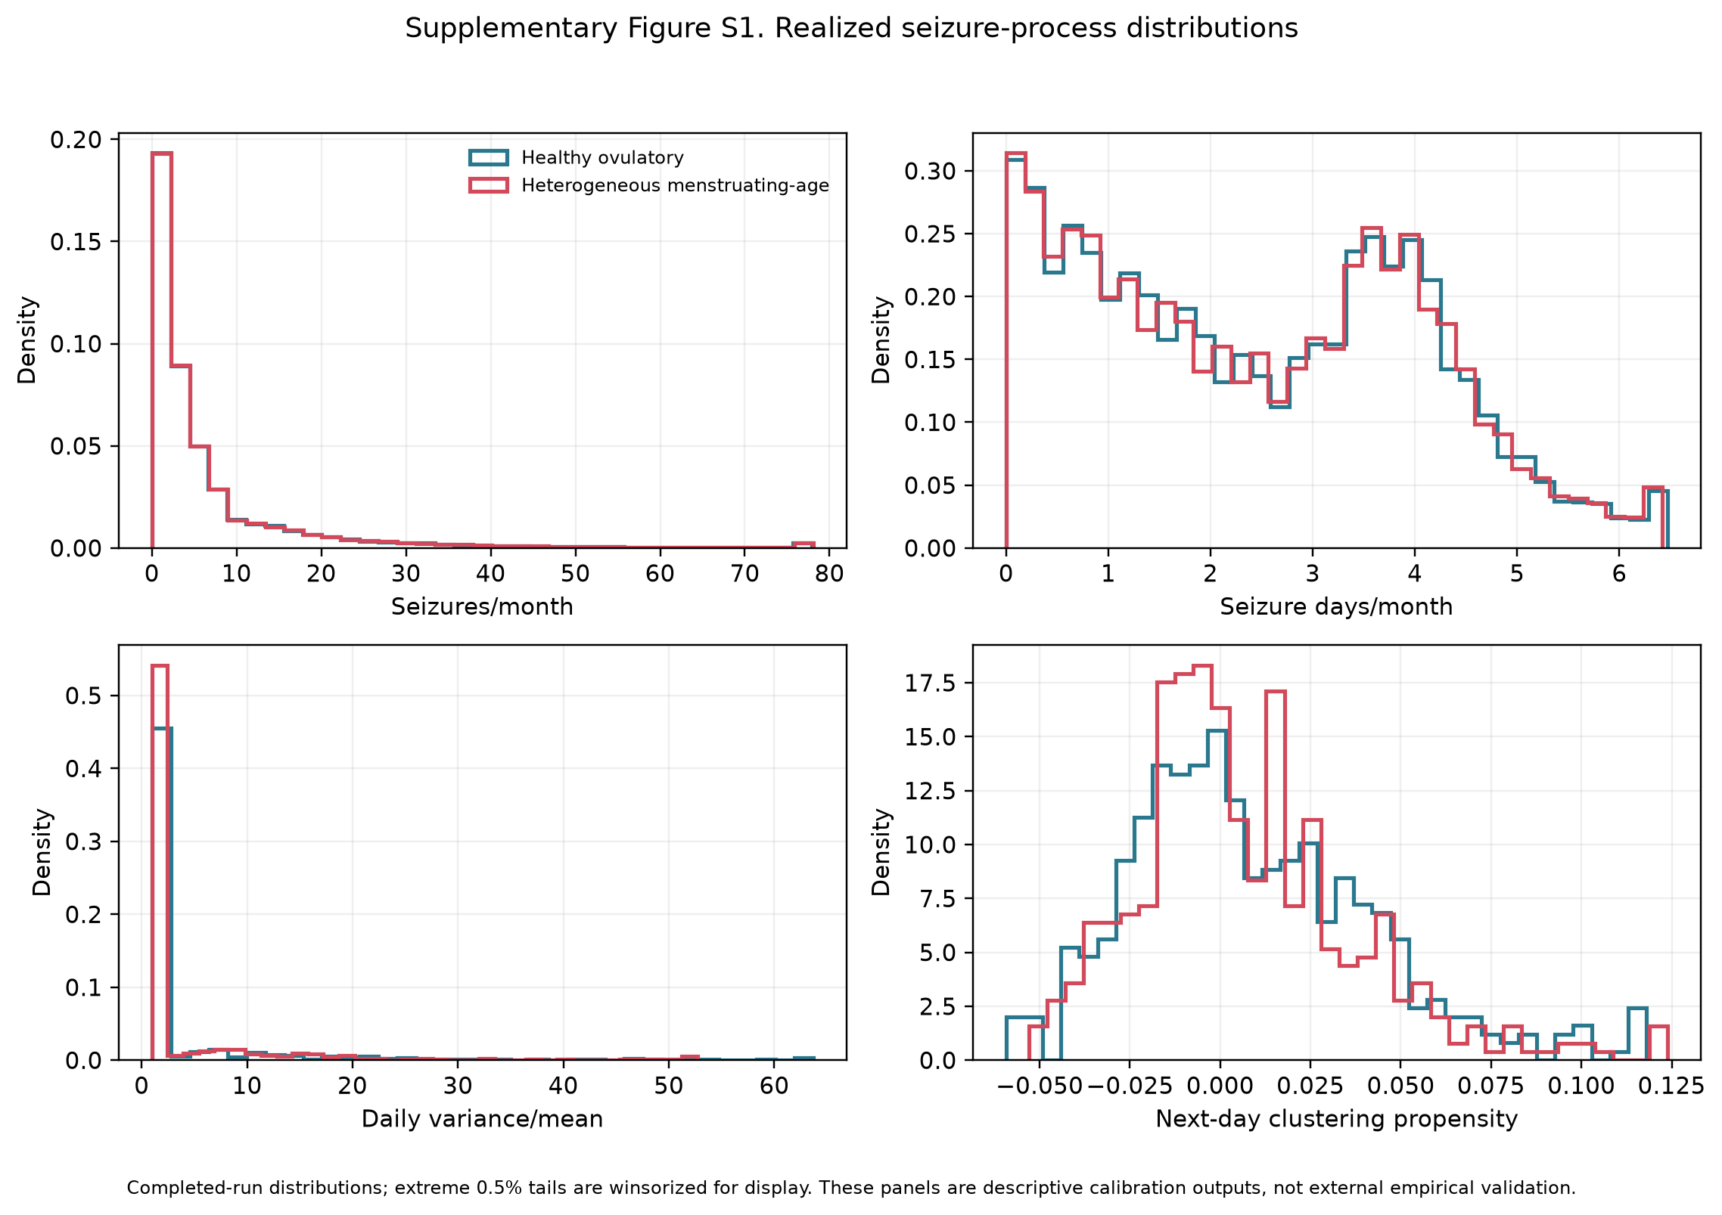
Supplementary Figure S1. Realized seizure-process distributions. Seizures per month and seizure days per month use all 50,000 participants in each cohort. Daily count variance divided by mean and next-day clustering propensity use the retained 1% daily audit sample of 500 participants per cohort. All panels display simulated data; monthly measures use 30-day months.
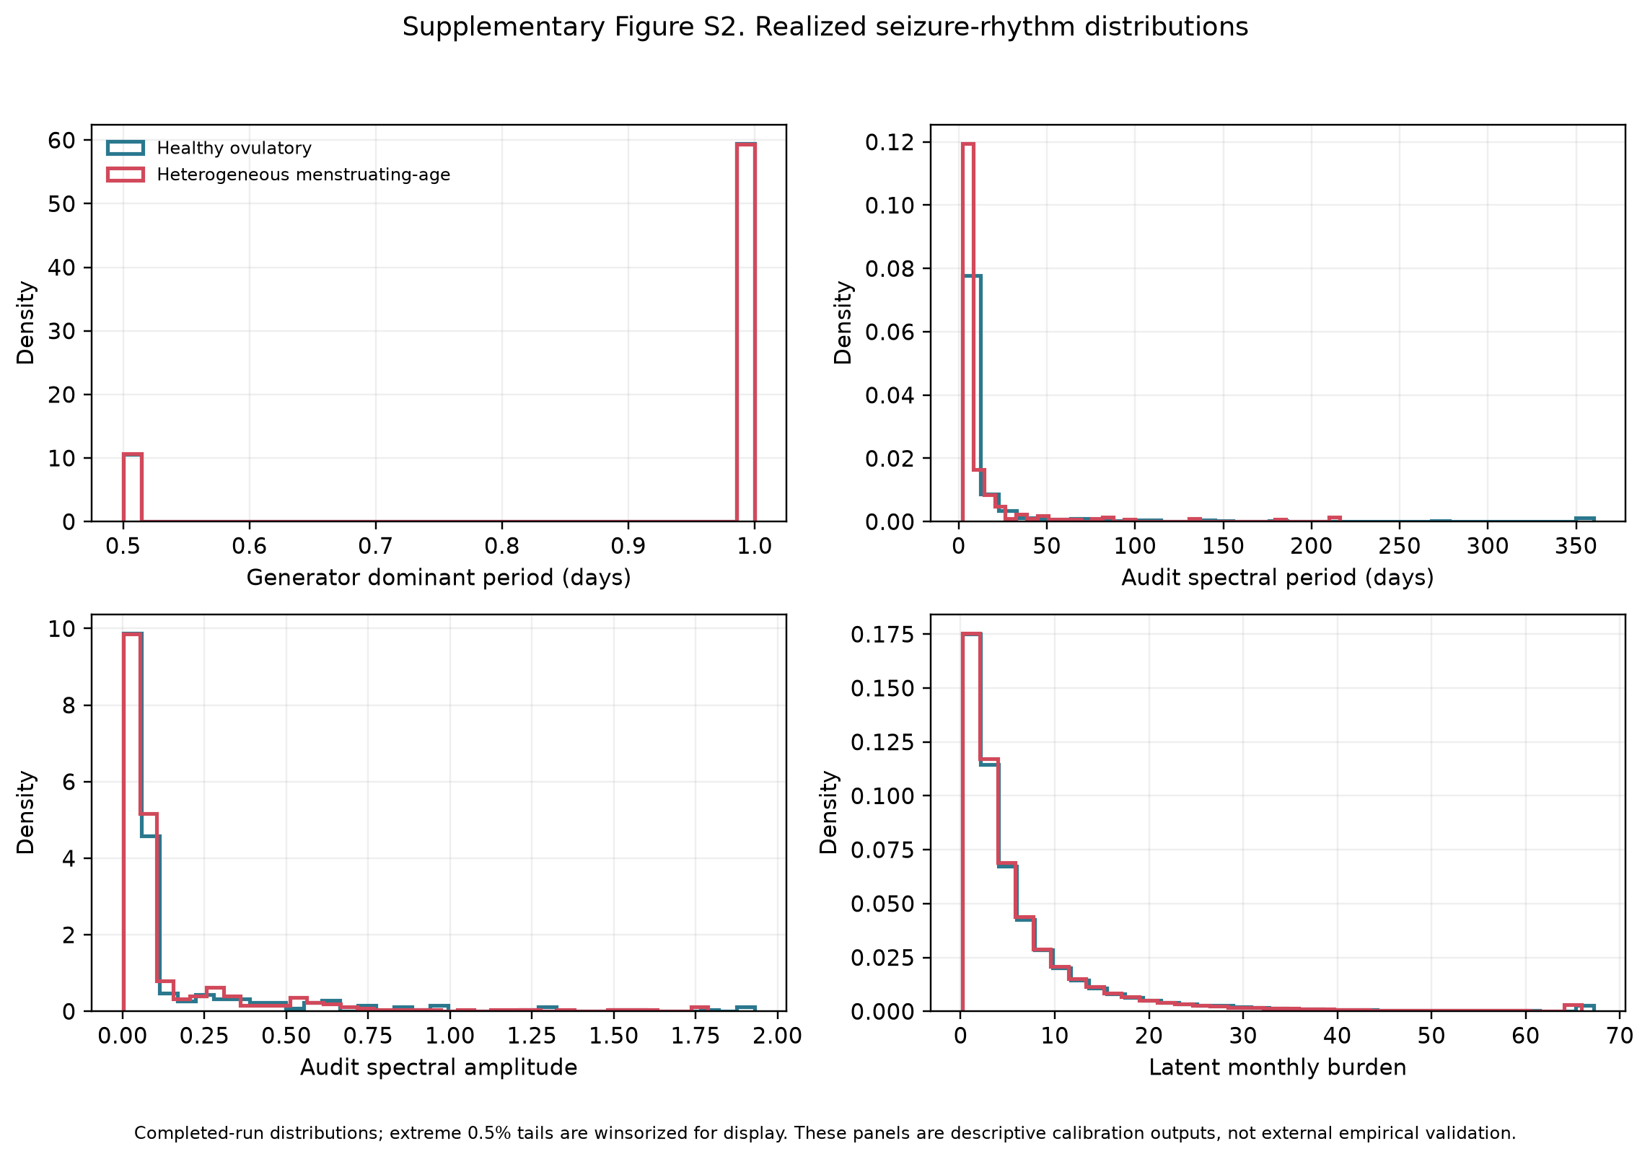
Supplementary Figure S2. Realized seizure-rhythm distributions. Generator-reported dominant period and latent monthly seizure burden use all 50,000 participants per cohort. Spectral period and amplitude use the retained 1% daily audit sample of 500 participants per cohort. Period is in days, spectral amplitude is in seizures per day, and burden is in seizures per 30-day month. All panels display simulated data.
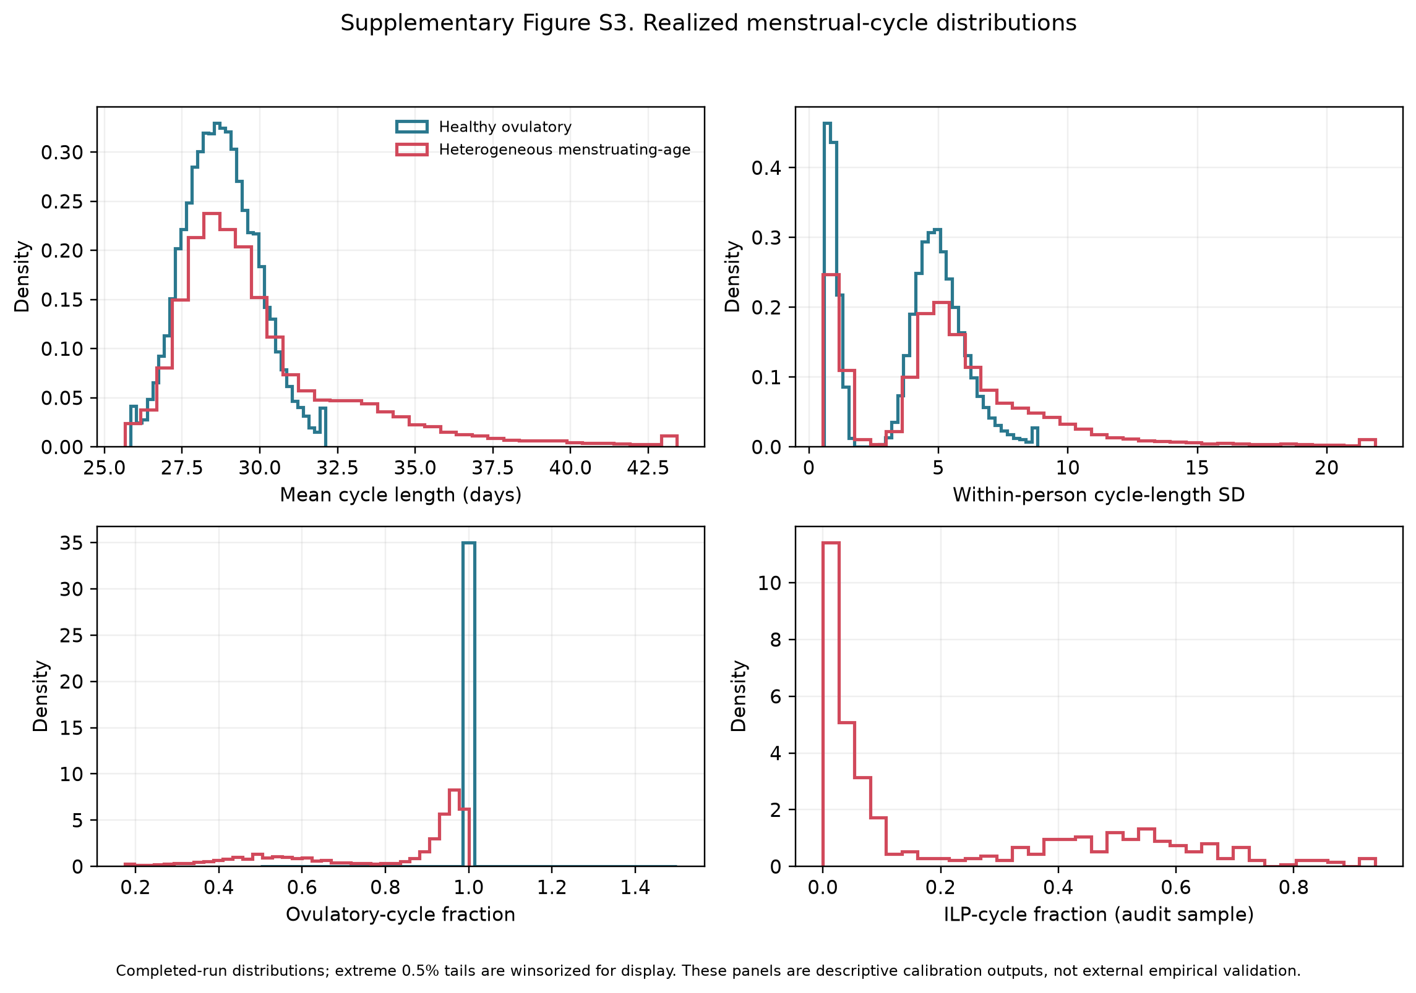
Supplementary Figure S3. Realized menstrual-cycle distributions in all 50,000 participants per cohort. Panels show mean cycle length in days, within-participant cycle-length standard deviation in days, ovulatory-cycle fraction, and inadequate luteal phase (ILP) fraction. The healthy cohort was generated with ovulation required. All panels display simulated data.
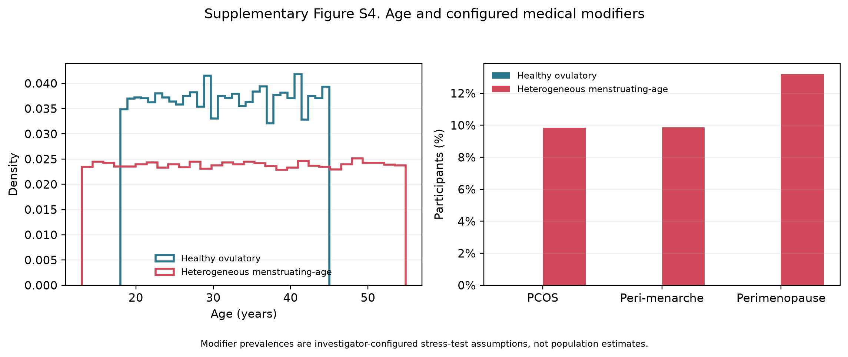
Supplementary Figure S4. Age and configured modifiers among all 50,000 participants per cohort. Polycystic ovary syndrome (PCOS) is abbreviated within the panel. Ages are in years. Modifier frequencies are investigator-configured heterogeneity stress-test settings and do not estimate population prevalence. All panels display simulated data.
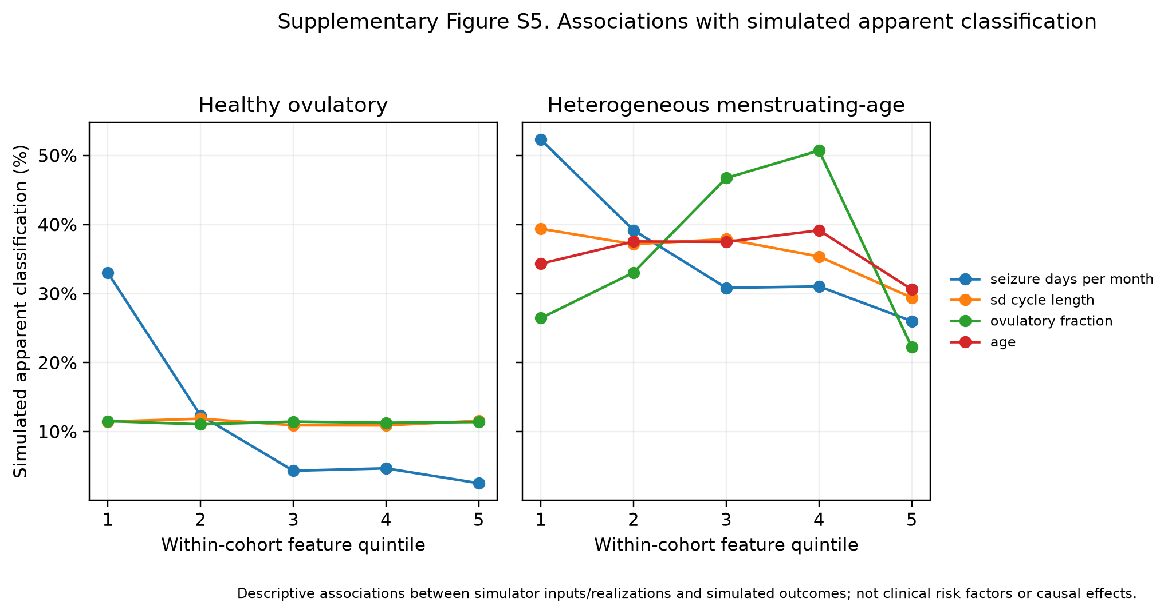
Supplementary Figure S5. Associations with false-positive classification under the independent null model across within-cohort feature quintiles. Each cohort contains 50,000 attempted participants; individual points use the classifiable denominator for the displayed definition. Error bars are 95% Wilson score confidence intervals. The display is descriptive and applies to the synthetic study population.

3.12 Interpretation of the supplementary analyses
The supplementary analyses quantify apparent catamenial classification under independence. They separate the perimenstrual (type C1), periovulatory (type C2), and inadequate-luteal-phase (type C3) patterns; preserve classifiable and all-attempted denominators; and show how diary duration, minimum-data requirements, ratio denominators, and inadequate-luteal-phase prevalence affect the estimates. Medication changes and secular trends are outside the simulation scope and remain limitations for translation to longitudinal clinical diaries.

References
1. Daniel Goldenholz. HORMONE-CYCLE [Python] [Python 3.11+]. GoldenholzLab; 2026. Available from: https://github.com/GoldenholzLab/catamenial-epilepsy-sim.git
2. Goldenholz DM, Westover MB. Flexible realistic simulation of seizure occurrence recapitulating statistical properties of seizure diaries. Epilepsia. 2023 Feb;64(2):396–405. doi:10.1111/epi.17471
3. Monks T, Currie CSM, Onggo BS, Robinson S, Kunc M, Taylor SJE. Strengthening the reporting of empirical simulation studies: introducing the STRESS guidelines. J Simul. 2019;13(1):55–67. doi:10.1080/17477778.2018.1442155
4. Burton A, Altman DG, Royston P, Holder RL. The design of simulation studies in medical statistics. Stat Med. 2006 Dec 30;25(24):4279–92. doi:10.1002/sim.2673 PubMed PMID: 16947139.
5. Li H, Gibson EA, Jukic AMZ, Baird DD, Wilcox AJ, Curry CL, et al. Menstrual cycle length variation by demographic characteristics from the Apple Women’s Health Study. NPJ Digit Med. 2023;6(1):100. Located at: 37248288. doi:10.1038/s41746-023-00848-1
6. Bull JR, Rowland SP, Scherwitzl EB, Scherwitzl R, Danielsson KG, Harper J. Real-world menstrual cycle characteristics of more than 600,000 menstrual cycles. NPJ Digit Med. 2019;2:83. Located at: 31482137. doi:10.1038/s41746-019-0152-7
7. Stricker R, Eberhart R, Chevailler MC, Quinn FA, Bischof P, Stricker R. Establishment of detailed reference values for luteinizing hormone, follicle stimulating hormone, estradiol, and progesterone during different phases of the menstrual cycle on the Abbott ARCHITECT analyzer. Clin Chem Lab Med. 2006;44(7):883–7. Located at: 16776638. doi:10.1515/CCLM.2006.160
8. Cunningham AC, Pal L, Wickham AP, Prentice C, Goddard FGB, Klepchukova A, et al. Chronicling menstrual cycle patterns across the reproductive lifespan with real-world data. Scientific Reports. 2024 May 3;14(1):10172. Located at: 38702411. doi:10.1038/s41598-024-60373-3
9. Harlow SD, Baird DD, Weinberg CR, Wilcox AJ. Urinary oestrogen patterns in long follicular phases. Hum Reprod. 2000 Jan;15(1):11–6. doi:10.1093/humrep/15.1.11 PubMed PMID: 10611180.
10. Mumford SL, Steiner AZ, Pollack AZ, Perkins NJ, Filiberto AC, Albert PS, et al. The utility of menstrual cycle length as an indicator of cumulative hormonal exposure. J Clin Endocrinol Metab. 2012 Oct;97(10):E1871-1879. doi:10.1210/jc.2012-1350 PubMed PMID: 22837188; PubMed Central PMCID: PMC3674299.
11. Anckaert E, Jank A, Petzold J, Rohsmann F, Paris R, Renggli M, et al. Extensive monitoring of the natural menstrual cycle using the serum biomarkers estradiol, luteinizing hormone and progesterone. Pract Lab Med. 2021 May;25:e00211. doi:10.1016/j.plabm.2021.e00211 PubMed PMID: 33869706; PubMed Central PMCID: PMC8042396.
12. Fraser IS, Critchley HOD, Broder M, Munro MG. The FIGO recommendations on terminologies and definitions for normal and abnormal uterine bleeding. Semin Reprod Med. 2011 Sep;29(5):383–90. doi:10.1055/s-0031-1287662 PubMed PMID: 22065325.
13. Mortimer R, Asokan G, Baird DD, Wilcox AJ, Abrams K, Curry CL, et al. Variability of menstrual cycles by age, polycystic ovary syndrome, and early-life cycle irregularity in the apple Women’s Health Study. Am J Obstet Gynecol. 2026 Apr;234(4):1042–69. doi:10.1016/j.ajog.2025.11.031 PubMed PMID: 41297783; PubMed Central PMCID: PMC12915291.
14. Doi SAR, Al-Zaid M, Towers PA, Scott CJ, Al-Shoumer KAS. Irregular cycles and steroid hormones in polycystic ovary syndrome. Hum Reprod. 2005 Sep;20(9):2402–8. doi:10.1093/humrep/dei093 PubMed PMID: 15932911.
15. Jarrett BY, Vanden Brink H, Oldfield AL, Lujan ME. Ultrasound Characterization of Disordered Antral Follicle Development in Women with Polycystic Ovary Syndrome. J Clin Endocrinol Metab. 2020 Nov 1;105(11):e3847-3861. doi:10.1210/clinem/dgaa515 PubMed PMID: 32785651; PubMed Central PMCID: PMC7473602.
16. Venturoli S, Porcu E, Fabbri R, Paradisi R, Ruggeri S, Bolelli G, et al. Menstrual irregularities in adolescents: hormonal pattern and ovarian morphology. Horm Res. 1986;24(4):269–79. doi:10.1159/000180567 PubMed PMID: 3491030.
17. World Health Organization multicenter study on menstrual and ovulatory patterns in adolescent girls. II. Longitudinal study of menstrual patterns in the early postmenarcheal period, duration of bleeding episodes and menstrual cycles. World Health Organization Task Force on Adolescent Reproductive Health. J Adolesc Health Care. 1986 Jul;7(4):236–44. PubMed PMID: 3721946.
18. Zhang K, Pollack S, Ghods A, Dicken C, Isaac B, Adel G, et al. Onset of ovulation after menarche in girls: a longitudinal study. J Clin Endocrinol Metab. 2008 Apr;93(4):1186–94. doi:10.1210/jc.2007-1846 PubMed PMID: 18252789; PubMed Central PMCID: PMC2291492.
19. Santoro N, Randolph JF. Reproductive hormones and the menopause transition. Obstet Gynecol Clin North Am. 2011 Sep;38(3):455–66. doi:10.1016/j.ogc.2011.05.004 PubMed PMID: 21961713; PubMed Central PMCID: PMC3197715.
20. Edelman A, Micks E, Gallo MF, Jensen JT, Grimes DA. Continuous or extended cycle vs. cyclic use of combined hormonal contraceptives for contraception. Cochrane Database Syst Rev. 2014 Jul 29;2014(7):CD004695. doi:10.1002/14651858.CD004695.pub3 PubMed PMID: 25072731; PubMed Central PMCID: PMC6837850.
21. Xiao B, Zeng T, Wu S, Sun H, Xiao N. Effect of levonorgestrel-releasing intrauterine device on hormonal profile and menstrual pattern after long-term use. Contraception. 1995 Jun;51(6):359–65. doi:10.1016/0010-7824(95)00102-g PubMed PMID: 7554977.
22. Barbosa I, Olsson SE, Odlind V, Goncalves T, Coutinho E. Ovarian function after seven years’ use of a levonorgestrel IUD. Adv Contracept. 1995 Jun;11(2):85–95. doi:10.1007/BF01987274 PubMed PMID: 7491859.
23. Hubacher D, Reyes V, Lillo S, Zepeda A, Chen PL, Croxatto H. Pain from copper intrauterine device insertion: randomized trial of prophylactic ibuprofen. Am J Obstet Gynecol. 2006 Nov;195(5):1272–7. doi:10.1016/j.ajog.2006.08.022 PubMed PMID: 17074548.
24. Faundes A, Segal SJ, Adejuwon CA, Brache V, Leon P, Alvarez-Sanchez F. The menstrual cycle in women using an intrauterine device. Fertil Steril. 1980 Nov;34(5):427–30. doi:10.1016/s0015-0282(16)45131-9 PubMed PMID: 7439408.
25. Malmqvist R, Petersohn L, Bengtsson LP. Menstrual bleeding with copper-covered intrauterine contraceptive devices. Contraception. 1974 Jun;9(6):627–33. doi:10.1016/0010-7824(74)90048-1 PubMed PMID: 4448089.
26. Dawood MY. Primary dysmenorrhea: advances in pathogenesis and management. Obstet Gynecol. 2006 Aug;108(2):428–41. doi:10.1097/01.AOG.0000230214.26638.0c PubMed PMID: 16880317.
27. Karoly PJ, Rao VR, Gregg NM, Worrell GA, Bernard C, Cook MJ, et al. Cycles in epilepsy. Nat Rev Neurol. 2021;17(5):267–84. Located at: 33723459. doi:10.1038/s41582-021-00464-1
28. Herzog AG, Klein P, Ransil BJ. Three patterns of catamenial epilepsy. Epilepsia. 1997;38(10):1082–8. Located at: 9579954. doi:10.1111/j.1528-1157.1997.tb01197.x
29. Herzog AG. Catamenial epilepsy: Update on prevalence, pathophysiology and treatment from the findings of the NIH Progesterone Treatment Trial. Seizure. 2015;28:18–25. Located at: 25770028. doi:10.1016/j.seizure.2015.02.024
30. Herzog AG, Harden CL, Liporace J, Pennell P, Schomer DL, Sperling M, et al. Frequency of catamenial seizure exacerbation in women with localization-related epilepsy. Ann Neurol. 2004;56(3):431–4. Located at: 15349872. doi:10.1002/ana.20214
31. Newcombe RG. Two-sided confidence intervals for the single proportion: comparison of seven methods. Stat Med. 1998 Apr 30;17(8):857–72. doi:10.1002/(sici)1097-0258(19980430)17:8<857::aid-sim777>3.0.co;2-e PubMed PMID: 9595616.
32. Aickin M, Gensler H. Adjusting for multiple testing when reporting research results: the Bonferroni vs Holm methods. Am J Public Health. 1996 May;86(5):726–8. doi:10.2105/ajph.86.5.726 PubMed PMID: 8629727; PubMed Central PMCID: PMC1380484.

